External Process Validation and Sampling guideline

Contents
1. Purpose 4
2. Scope 4
3. Process Validation Overview 4
3.1 Process Validation Elements 4
3.2 Critical Quality Attributes 6
3.3 Verification versus Validation Decision 6
3.4 Processes that are expected to be validated 7
3.5 Full Verification during Commercial Manufacturing 8
3.6 Process Validation Expectations 8
3.7 Achieving the planned result 9
3.8 Process Validation Types 9
3.9 Personnel Qualification 10
4. Acronyms and Definitions 11
5. Process Validation Plan 15
6. Installation Qualification (IQ) 16
6.1 IQ Applicability 16
6.2 IQ Prerequisites 16
6.3 Equipment Requirements 16
6.4 IQ Protocol 17
7. Operational Qualification (OQ) 22
7.1 Equipment Suitability 23
7.2 Number of required OQ runs 23
7.3 Number of manufactured samples 23
7.4 Process Characterization 23
7.5 OQ Prerequisites 26
7.6 Worst-Case Definition 27
7.7 OQ Protocol 27
8. Performance Qualification (PQ) 32
8.1 Nominal Setpoint versus Normal Operating Range 32
8.2 Number of required PQ runs 33
8.3 Number of manufactured samples 33
8.4 PQ Prerequisites 33
8.5 Protocol 34
9. Test Method Validation 38
10. Sampling Plans for Process Validation 39
10.1 Risk-Based Sampling Plans 39
10.2 Sampling Plan Assumptions 39
10.3 Confidence and Reliability 40
10.4 Sampling Plan Rationales 41
10.5 Sampling Plan Confidence and Reliability Statement 41
10.6 Attribute sampling plans for 95% Confidence 42
10.7 Attribute sampling plans for 90% Confidence 43
10.8 Variable Sampling Plans for PQ 44
10.9 Variable Sampling Plans for OQ 45
11. Procedure 46
11.1 Select Reliability and Sampling Plan 46
11.2 Document Rationale 46
11.3 Sample Pooling 46
11.4 Analyze Results (Attribute Data) 46
11.5 Analyze Results (Variable Data) 46
11.6 Document Test Results 47
11.7 Confidence Statement 47
12. Sampling strategies for Low Volume production 48
13. Normality Testing (Using Minitab) 49
13.2 When Normality Tests Fail 50
14. Calculating Ppk and Pp 51
15. Manual Processes 53
15.1 Establishing Repeatable Manual Processes 53
16. Revalidation 53
17. Decision Flow Chart 55
18. References 56
19. Appendix, Rationale for Sampling Plan Approach 57
19.1 Approach to Attribute Single Sampling Plans 57
19.2 Approach for Variable Sampling Plans 58
19.3 Pp/Ppk versus Cp/Cpk 63

Purpose
This guideline is in close alignment with GHTF/SG3/N99-10:2004 Ed2, Quality Management Systems Process Validation Guidance.

Scope
This guideline applies to external suppliers and supports the Philips APQP process. Refer to the local QMS for internal process validation procedures. This guideline provides minimum requirements to suppliers when performing process validation for Philips’s parts, sub-assemblies, and products. Suppliers should follow their own quality management system to execute process validation, however, when there is misalignment with this guideline, justification and approval from Philips is required prior to process validation protocol execution. Additionally, if a supplier were to choose to use a lower reliability sampling plan in production, written approval must be provided by a Philips Quality Engineering.

Process Validation Overview
International regulations and standards (ISO 13485) require that manufacturing processes for medical devices are validated when one or more process outputs cannot or are not fully verified by subsequent inspection or test during commercial manufacturing. The term ‘device’ applies to components/parts, subassemblies, and finished products and systems.

Process validation consists of demonstrating the ability of processes to consistently achieve planned results (including rework) with a high degree of assurance. This is achieved by demonstrating and documenting control of the critical process parameters (CPPs) and documented verification that all Critical to Quality Attributes (CQA) of the product or process output meet the predetermined acceptance criteria.

Process Validation Elements
Process validation consists of the following activities:

Installation Qualification (IQ): All equipment used in the manufacturing and testing of medical parts, elements, and products are qualified. Installation Qualification (IQ) is required to provide objective evidence that the equipment has been installed per the manufacturer’s recommendations and performs as intended.

Test Method Validation (TMV): Test Method Validation (TMV) is required for the full verification of CQAs in production and for test methods used during process characterization, OQ, and PQ.

Operational Qualification (OQ): The purpose of the Operational Qualification (OQ) is to establish by objective evidence that the process control limits and action levels within which a product is produced meet predetermined requirements.

Bracketing: If several products within a product family can be documented within the protocol to be equivalent through an engineering rationale (e.g. extruded tubes of equal ID and OD but varying lengths), a process OQ can be executed to qualify a process using a product representative of the family. If such equivalency cannot be established, then an OQ must be run for each product being validated.

For manual processes, with no parameter adjustments, an OQ may not be required. Fully automated processes where all CPPs are fixed (no operating range) the OQ may not be required. In that case Performance Qualification will satisfy the validation requirements since all CPP’s are fixed and the natural process variation is captured in the PQ.

Performance Qualification (PQ): The purpose of Performance Qualification (PQ) is to establish by objective evidence that the process, under anticipated conditions, consistently produces a product which meets predetermined requirements.

Environmental conditions (temperature, relative humidity), variation between duplicate equipment, variations in (received) material and components lots, varying operator skill, etc. should be considered in the planning of the validation.

The number of PQ runs, and lot sizes chosen must be based on statistically documented rationale to achieve the specified level of confidence. The lots must yield acceptable results in consecutive, successful validation runs.

Bracketing: If several products within a product family can be documented within the protocol to be equivalent through an engineering rationale (e.g. extruded tubes of equal ID and OD but varying lengths), a process PQ can be executed to qualify a process using a product representative of the family and/or by running the product through all the standard operations as a process flow. If such equivalency cannot be established, then a PQ must be run for every product. When the validated product family is extended, the original protocol is updated with the extended product, and a rationale for inclusion of the new product into the validated family is provided in the protocol.

Figure 1 depicts an example of the equipment’s operating range that is qualified during IQ, the process window that is developed and challenged in OQ for a specific process, and the typical operating range during PQ and normal manufacturing.
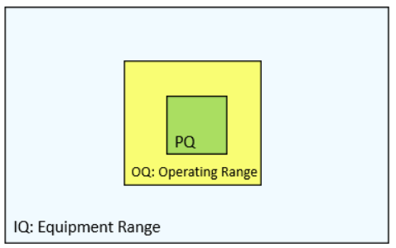
Figure 1: Typical Equipment Range
Typical flow of a process validation project.
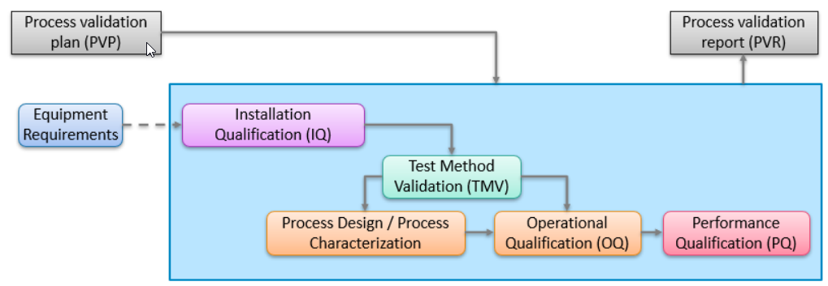
Figure 2: Process validation flow and steps

Additional points to consider for process validation are the use of statistically based sampling plans, establishing a Manufacturing Control Plan (may also be called Quality Control Plan) to describe monitoring and testing activities during commercial manufacturing, documenting revalidation requirements, establishing periodic reviews of validated processes and revalidating as required, and using good documentation practice.

Critical Quality Attributes

Philips uses a Critical Quality Attribute (CQA) classification scheme to prioritize and communicate the need for applying more stringent control levels to product characteristics with high impact on safety, effectiveness, compliance, attractiveness of the product, or the manufacturing process.

Critical Quality Attributes are either Critical to Safety (CTS), Critical to Quality (CTQ), or Key Process Indicators (KPI). The CQAs must be 100% inspected in routine production unless the process is validated. After the process is validated, the CQAs are monitored in routine production as documented in the Manufacturing Control Plan.

A characteristic is classified as CTS (Critical to Safety) when failure to meet this requirement or design specification is conceivable and failure could lead to serious harm to the patient, user, property, or the environment. CTS classification is determined by the Philips Risk Management Team during the development process. Severity of Harm (SOH) ranking is S0, S1, S2, S3, and S4, where S3 and S4 are considered serious.

A characteristic is classified as CTQ (Critical to Quality) when failure to meet this requirement or design specification is conceivable and failure could lead to a severe negative impact on quality, i.e., effectiveness, compliance, or attractiveness of the product. CTQs are identified in the early design phase and confirmed in the Design FMEA. Severity of Effects (SOE) levels are SEV1, SEV3, SEV5, and SEV8.

In certain scenarios, a non-CTQ, non-CTS characteristic is classified as a KPI (Key Process Indicator) as explained here:
- When a non-CTQ, non-CTS characteristic should be inspected in routine production using a primary test method, the characteristic must be classified as a KPI. KPIs may not be indicated as such in the Philips drawing but need to be identified and agreed upon when the SRPQP is filled out and approved. KPIs may be identified by Philips engineers or suppliers.
- When a product characteristic cannot be fully verified and when this characteristic is not classified as a CTQ or CTS, then it must be classified as Key Process Indicator. For example, when bond strength is not classified as CTQ or CTS, it must be classified as Key Process Indicator, and the bonding process must be validated accordingly. When there is no adequate specification for a non-verifiable quality attribute (e.g., no bond strength is specified), Philips Engineering must be consulted for a specification.

Verification versus Validation Decision
Validation of processes must be conducted when the resulting output cannot or is not fully verified by subsequent inspection and testing via monitoring or measurement, and when deficiencies may become apparent only after the product is in use or the service has been delivered.

Some processes cannot be verified by testing all critical quality attributes (CQAs) or performing such tests may not be practical (e.g., due to batch size or destructive testing). In such cases, the process must be validated to ensure that it can reliably produce acceptable output. Some but not all examples of processes that are not or cannot be fully verified are listed in chapter 3.4. Figure 3 depicts a decision tree.

In cases where all product characteristics are confirmed through Risk Management documents to not pose any patient risk and are confirmed to be a truly cosmetic defect that does not impact function, the validation team may propose that a special process may not require an OQ or PQ. OQ or PQ may only be exempted if the proposal is approved by a Philips Quality Representative or a Philips Supplier Engineering manager and documented in the SRPQP.

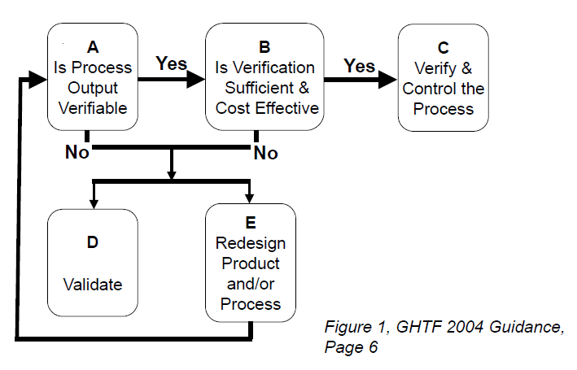
Figure 3: GHTF SG2-N99-2004 Guidance for Validation versus Verification

Processes that are expected to be validated
The following manufacturing processes are expected to be validated.

Note: This is not a comprehensive list. Each process should be assessed as described in the previous chapter.
- injection molding
- plastics extrusion
- adhesive bonding (glueing)
- plastic bonding (ultrasonic welding, thermal bonding)
- annealing and heat treating
- welding (laser welding, fuse welding, ultrasonic welding)
- soldering (wave soldering, manual soldering, reflow soldering)
- casting
- sterilization
- sterile package sealing
- plating
- cleaning and removal of processing agents

Reasons for validating these processes are (but not limited to):

Some process outputs can only be verified by a destructive test (bond strength, solder strength, seal integrity, sterility, weld integrity, etc.).

Uncontrolled variation or changes to critical process parameters may alter the functional performance of a part or device which only becomes apparent after the product has been in use. For example:

Lowering the mold temperatures during injection molding may cause a noticeable deformation (warpage) when the part is in use.

Reducing the drying time of raw material for extrusion may lead to fractures in a catheter during use.

Lowering the soldering temperature may lead to a printed circuit board failure because the solder connection may be too brittle to withstand vibration.

For some processes, verification alone may not be sufficient. For example, crimp height can be fully verified for a crimping process. However, inspecting crimp height alone may not be sufficient because it does not prove that the wire is fully secured inside the terminal. A pull test should be performed to demonstrate that the wire is fully secured and not likely to loosen during normal use.

Full Verification during Commercial Manufacturing
Full verification means 100% inspection. If no process validation is conducted, the Critical Quality Attributes (CtQ, CtS, Key Process Indicator) must be 100% inspected. 21 CFR 820.3 (aa) states, Verification means confirmation by examination and provision of objective evidence that specified requirements have been fulfilled.

Process Validation Expectations
MDSAP audit approach is an Internationally acknowledged approach to process validation. The following items must be complete for a successful process validation project:

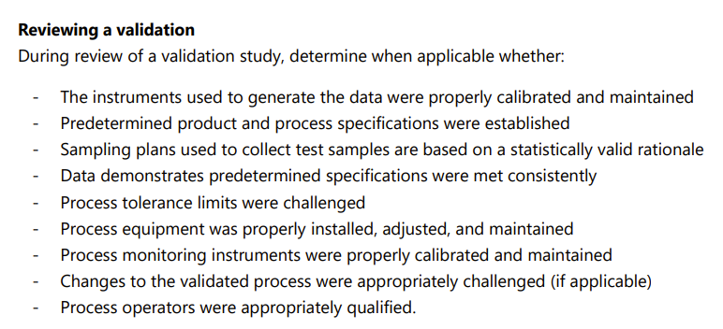
Figure 4: MDSAP Audit Approach to Validation.

Achieving the planned result
The MDSAP audit approach states that process validation activities are predictive, rather than empiric. For a process validation study to show the process achieves the planned result, the acceptance criteria must be stated in advance of performing the validation. The data from the process validation study must confirm that the predetermined acceptance criteria have been met.

Process Validation Types
Process Validation executed on behalf of Philips may be executed in multiple different methods, as described below:

Prospective Validation
Validations conducted prior to release or distribution of a new or redesigned part or product, or part or product made under an updated process, where the changes may affect the part or product’s form, fit or function. Typically, multiple lots are required to demonstrate process capability and consistency, and no lots are released until all lots are tested successfully and a report is released. The validation type decision and justification are documented in the process validation plan. Prospective validation is the preferred method.

Retrospective Validation

Validation of a process based on accumulated historical production, testing, control, and other information for a product already in production and distribution.

Retrospective PQ establishes confidence that the current process is effective and reproducible by the sole use of historical data. To justify the use of retrospective validation, all test methods used in the primary inspections or tests must have been validated. Additionally, if the process uses computerized data collection, the data and collection means must also have been validated to ensure data integrity.

This historical data may be found in batch records, production logbooks, lot records, control charts, test and inspection results, customer complaints, audit reports, etc.

Retrospective validation is feasible when all the appropriate data (including process parameter settings) was collected in a manner that allows adequate analysis and is of the same quality that would be required in prospective validation. Historical manufacturing data of a pass/fail nature alone (e.g. sample size not described, actual results not recorded, etc.) is usually not adequate.

If historical data is determined to be adequate and representative, an analysis can be conducted via a written retrospective validation protocol to determine whether the process has been operating in a state of control and has consistently produced product which meets its predetermined requirements.

If the retrospective data review satisfies the minimum performance levels required for each quality parameter, then the operating range in the manufacturing instructions will be changed to the widest range found based on the actual data found for the lots during that period and the process will be deemed successfully retrospectively validated. A minimum of 20 production runs should be used for analysis. If there was a change to the manufacturing process, then only runs after the change can be used for analysis.

The validation type decision and justification for retrospective validation are approved by Philips and documented in the SRPQP.

Concurrent or Rolling Validation

The PQ study needs to be completed successfully and a high degree of assurance in the process must be achieved before the commercial distribution of product. In special situations, the PQ protocol can be designed to release a PQ run to distribution before complete execution of the PQ study. It is recommended to only use this approach when all CQAs can be fully verified. Pooling data may not be used in cases of concurrent validation. FDA expects that concurrent release will be rarely used.

Concurrent validation should follow the prospective validation approach described in this guidance. IQ, TMV, and OQ must be completed, and respective reports approved before PQ commences. In rare cases the PQ runs can be released concurrently meaning that product made from PQ 1 can be released to market before PQ 2 commences. Product can only be released after the requirements of the protocol have been met, and an interim report is approved.

A rolling validation can be considered for low volume manufacturing when the required sample size for a PQ attribute sampling plan is higher than the commercial lot size. Circumstances and rationale for the concurrent release must be described in the PQ protocol and approved by Philips Quality Engineering. For example, a low volume sandcasting process may require ten production runs to meet the attribute sampling requirement. For the PQ study, the manufactured parts can be released after each PQ run if all acceptance criteria and requirements are met before releasing each lot. Critical Quality Attributes need to be 100% verified. Once enough samples have been inspected to meet the attribute sampling plan criteria, the final report is written, and the process is then considered validated. Since Philips only uses attribute sampling plans with c=0 failures for process validation, no failure is allowed during the concurrent validation study. If a failure occurs, the validation study fails and full verification of CQAs must continue until a new validation study has been successfully completed.

Personnel Qualification

Validated processes must be executed by qualified personnel.

21 CFR 820.75 (b) (2) states that each manufacturer shall ensure that validated processes are performed by qualified individual(s).

CFR 820.25 (b) (2) states that personnel who perform verification and validation activities shall be made aware of defects and errors that may be encountered as part of their job functions.

Each person participating in the execution of validation activities must be trained to the validation protocols (IQ, OQ, PQ) and the training records must be retained with the validation records.

Acronyms and Definitions
Acronyms and Terminology | Description
Action Level | An established point at which a critical process parameter (CPP) or a critical quality attribute (CQA), as measured during the manufacturing process, indicates a need for action/adjustment to the CPP, to maintain a state of control.
AQL | Acceptance Quality Level. The AQL of a sampling plan is a quality level routinely accepted by the sampling plan. The AQL describes the quality levels the sampling plan accepts at least 95% of the time.
Binomial Distribution | The binomial distribution is a discrete function that is used to describe a process where the outcomes can be labeled as pass or fail and when we are interested in the occurrence of a failure and not in its magnitude.  For example, use the binomial distribution to calculate the probability that 3 or more defectives are in a sample of 25 items if the probability of a defective for each trial is 2%. The number of defective items (X) follows a binomial distribution with n = 25 and p = 0.02 (Paraphrased from Minitab Help)
CDRH | FDA Center for Devices and Radiological Health  Branch of the United States Food and Drug Administration responsible for medical devices regulation
Common cause variation | Common cause variation is the expected, random fluctuation in a process that results from normal interactions between process operators, equipment, materials, environment, and methods. A process that only has common cause variation is consistent and predictable.
Confidence Statement | Passing a sampling plan allows one to make a confidence statement such as: With 95% confidence, more than 99% of the product meets the predetermined specifications. The confidence level is the probability of rejecting a process with a quality level at AQL or better.
Concurrent Validation | Concurrent validation is an approach to process validation where the PQ lots are released for distribution before the complete validation study is approved, based on data from each individual PQ lot.
COTS | Commercial off -the-shelf
CPP | Critical Process Parameter (CPP). A CPP is a process parameter whose variability has an impact on a critical quality attribute. CPP’s must be identified before a process is validated, a process operating window must be established, challenged in the OQ, and confirmed in the PQ. CPP’s must be monitored or controlled in routine production to ensure the process meets the predetermined specifications.
CQA | Critical quality attribute (CQA). CQAs are essential to guarantee product safety and product quality. CQA’s include CTS’s, CTQ’s, and KPI’s (Key Process Indicators). By requirement, CQA’s are fully verified in routine production unless the process is validated.
CTQ | Critical to Quality: A characteristic is classified as CTQ when failure to meet this requirement or design specification is conceivable and failure could lead to a severe negative impact on Quality, i.e., effectiveness, compliance or attractiveness of the product.
CTS | Critical to Safety: A characteristic is classified as CTS when failure to meet this requirement or design specification is conceivable and failure could lead to serious* harm to the patient, user, property or the environment (* S3 or S4).
Deviation | Deviation means not following the prescribed protocol, e.g., sequence, materials, equipment, methods, or acceptance criteria during execution. All deviations must have an evaluation and / or assessment of the impact of the deviation.
Disposition of Materials | In the context of process validation, “disposition of materials” is the definition (and execution) of a predetermined arrangement/plan for how to manage parts/elements/products used in a process validation context. The disposition of materials should be defined prior to the execution of a process validation activity, and the execution of that disposition is performed after completion of the process validation activities.
DMR | Device Master Record: means a compilation of records containing the procedures and specifications for a finished device. Source: 21 CFR 820.3 (j)
Factors | Inputs inherent to the process that impact the nature of the manufacturing process (i.e., temperature, pressure, time, shift, type of material). The factors are the independent variables manipulated during the experiment.
Failure | Failure means that one or more of the following (but not limited to) are not met: requirement, acceptance criteria, defined activity, and / or prerequisite. Failure requires revalidation.
FMEA | Failure Mode and Effects Analysis.
IM&TE | Inspection, Measurement and Testing Equipment
Inspection Lot Size | When a sampling plan is applied in manufacturing the sample size and acceptance criteria is applied to an inspection lot. The inspection lot is defined as a group of material that is to be accepted or rejected as a group. It may also be a period such as 8 hours of production. The inspection lot should be expected to be of similar quality [Ref 2].
IQ | Installation Qualification: establishing by objective evidence that all key aspects of the process equipment and ancillary system installation adhere to the manufacturer’s approved specification and that the recommendations of the supplier of the equipment are suitably considered.  (GHTF/SG3/N99: 2004 ed 2)
KPI | Key Process Indicator.
LSL | Lower Specification Limit
Operating Limits | Limits for the process inputs that are established during process characterization and challenged during OQ.
OQ | Operational qualification: To challenge and confirm, with objective evidence, that process operating limits, process control limits, and action levels identified during Process Characterization, results in product that meets all predetermined requirements.
PD | Process Design: Process design is the activity of defining the commercial manufacturing process. The goal of process design is to develop a process suitable for routine commercial manufacturing that can consistently deliver a product that meets its quality attributes.
PC | Process Characterization: Collection of studies to support identification of significant process input windows during process development or modification, to be then confirmed and validated through the completion of the operational qualification (OQ) runs.
PFMEA | Process Failure Mode and Effects Analysis
PLC | Programmable Logic Controller
Pp | A capability index that compares the width of the specification limits to the width of the process (assumed to be 6 standard deviations wide). It assumes a two-sided specification limit. A value of 1 means the two widths are the same, making the specification limits 6 standard deviations wide. A value of 2 means the specification limits are twice as wide as the process, making the specification limits 12 standard deviations wide. A value of 0.5 means the specification limits are half as wide as the process, making the specification limits 3 standard deviations wide. Pp is a higher-the-better index.
Ppk | A capability index based on the distance to the nearest specification limit. The higher P_{pk} is, the further the process is from the nearest specification. P_{pk} is a higher-the-better index. A value of 1 means the average is 3 standard deviations from the specification limit. Assuming the normal distribution, this corresponds to 0.13%* nonconforming. A P_{pk} value of 1.333 means the average is 4 standard deviations from the specification limit. Assuming the normal distribution, this corresponds to 0.0032%* nonconforming or 32 defects per million (DPM). A P_{pk} value of 0.667 means the average is 2 standard deviations from the specification limit. Assuming the normal distribution, this corresponds to 2.3%* nonconforming (* - for one-sided specification).
PQ | Performance Qualification: establishing by objective evidence that the process, under anticipated conditions, consistently produces a product which meets all predetermined requirements. (GHTF/SG3/N99: 2004 ed 2)
Process Input | A process input refers to the materials, information, and resources that go into a process. It is supplied to the process from an external source. For instance, raw materials are considered a process input. The term process input is used interchangeably with process parameter in this document.
Process Input Control Limits | Process input data may be gathered and charted over time on control charts, and the upper and lower control limits are computed from available data. When process input data follows a random distribution located within the control limits, the process input is said to be stable, consistent, and predictable. When process input data follow patterns or are located outside the control limits, the process input may no longer be stable or predictable.
Process Output Control Limits | Process output data may be gathered and charted over time on control charts, and the upper and lower control limits are computed from available data. When process output data follows a random distribution located within the control limits, the process is said to be stable, consistent, and predictable. When process output data follow patterns or are located outside the control limits, the process may no longer be stable or predictable.
Process Parameter | A process parameter is a setting, condition, or variable that can be adjusted or controlled within the process itself to influence how the process runs and what outputs are produced.
Process Validation | Process validation means establishing by objective evidence that a process consistently produces a result or product meeting its predetermined specifications. Source: 21 CFR 820.3 (z) (1)
Product | Product means components, manufacturing materials, in- process devices, finished devices, and returned devices. Source: 21 CFR 820.3 (r)
Production equivalent | A part, component, sub-assembly or finished device that is representative of future production in the design specification, manufacturing process documentation (DMR) and manufacturing equipment.
Prospective Validation | Prospective means: concerned with or applying to the future. Prospective validation is the process of validating a manufacturing process before commercial production begins or before a change to an existing process is implemented.
PVP | Process validation plan
Retrospective Validation | Any validation that uses historical data to perform the validation. This approach is used for revalidating existing processes where periodic revalidation is required and for correcting deficiencies in earlier validations.
RQL | Rejectable Quality Level. The RQL of a sampling plan is a quality level which is routinely rejected by the sampling plan. Processes with defect rates equal to or worse than RQL are rejected most of the time.
S, SEV | Severity. Relative ranking of potential or actual consequences of a failure or fault. Source: Failure modes and effects analysis/IEC 60812:2018
Special Cause Variation | Special cause variation refers to unexpected glitches in the process. These variations are sporadic, unusual, and non-quantifiable. In a control chart, this type of variation is typically observed with data points outside of the control limits.
Transfer Function | Mathematical function that models the process output for each process input (i.e., Pressure, Time, Temperature).
TMV | Test Method Validation: Documented evidence of the reliability of the measurement system.
USL | Upper Specification Limit
WI | Work Instruction: Documented detailed descriptions of how to perform and record tasks. Work Instructions may be, for example, detailed written descriptions, flowcharts, templates, models, technical notes incorporated into drawings, specifications, equipment instruction manuals, pictures, videos, checklists, or combinations thereof. Work instructions should describe any materials, equipment, and documentation to be used. When relevant, work instructions include acceptance criteria.
Worse Case condition | Worst-case conditions are the settings for process inputs that cause the worst-case performance for the process outputs. Process inputs are typically set to their respective process limits. The process is challenged at the worst-case conditions during OQ to confirm that the process produces products that meet the predetermined requirements under all conditions of manufacturing.
Table 1: Acronyms and Definitions

Process Validation Plan
During the planning of product realization, the medical device organization must determine which production processes require validation and which process outputs can be sufficiently verified. The decision is typically documented in a Process validation plan (PVP). The PVP provides a general framework for the validation project and lays out the overall strategy, objectives, and requirements for validating the manufacturing process. A PVP is not required but highly recommended for processes where multiple manufacturing steps are executed, such as the manufacturing of cable assemblies where cable is cut to length, wires are soldered or crimped to connectors, and the connectors are then over molded and subsequently tested.

In cases where the process uses custom software to control the process or test method, software validation requirements should be included in the PVP. Software validation requirements are typically completed prior to OQ and PQ to ensure the software is performing as intended prior to its use in process validation activities.

The purpose of the PVP is twofold. One, to plan the validation and two, to provide objective evidence that the process validation activities were executed. The PVP should include a Purpose and Scope statement, should describe the product being made, should describe the processes that are being qualified, and should provide an overview of the validation strategy. Validation strategies include the type of planned validation (retrospective versus prospective), whether the process is validated for a sole product or for a group of products, etc.

The PVP should detail the revalidation requirements for the product or process. The PVP is intended to be a living document and as revalidations are performed, new protocols and reports should be recorded in the PVP, so it always contains the most current validations on file.

The PVP should list each process step and the related equipment and critical quality attributes (CQAs). For each piece of equipment, a decision is recorded if the equipment requires software validation and/or IQ, and for each CQA a decision is recorded to either be fully verified or to execute OQ and PQ. TMV is required for all primary inspection activities. A rationale for each decision is provided. Record NR for Not Required and R for Required. Once the protocols and reports are approved, the R’s are replaced by the protocol and report numbers. An example of a summary table is shown in Table 2.

Process ID | Process Name | Equipment Name | Process Output | Severity  CTQ/CTS | SWV¹ | IQ | TMV | OQ² | PQ² | Rationale
10 | Over molding | Mold | Length = 25mm ± 1mm | CtQ-SEV2 | NR | R | R | R | R | No Software
10 | Over molding | Mold | Pull Strength = 100 N min. | KPI | NR | R | R | R | R | No Software
Table 2: Example of a Summary Table in a Process Validation Plan
¹SWV = Software Validation (applies to custom software which is executed separately from IQ).
²R on OQ and/or PQ implies that process is being validated.

Installation Qualification (IQ)
According to the GHTF guidance [Ref-1], IQ is defined as establishing by objective evidence that all key aspects of the process equipment and ancillary system installation adhere to the manufacturer’s approved specification and that the recommendations of the supplier of the equipment are suitably considered.

IQ establishes a foundation for other qualification activities by assuring the equipment is properly constructed, placed, and installed to facilitate maintenance, adjustment, cleaning, and use. Calibration is also an important facet of IQ as it ensures the instrumentation used to measure process inputs and process outputs meets accuracy requirements and is operating within its specified tolerances.

IQ Applicability
IQ applies to the qualification of equipment used to manufacture, test, assemble, label, and package medical devices (parts, elements, products, systems).

IQ is typically not required for hand tools like screw drivers, hammers, pliers, etc. unless these tools are customized for a specific process and use.

Simple off-the-shelf catalog equipment without software and without utilities such as calipers, micrometers, pin gauges, voltmeters, etc., do not require qualification as long as the need for calibration and preventive maintenance is assessed, and if required, the equipment is added to the local calibration and/or preventive maintenance systems. The functionality is defined and verified by the calibration process. The suitability and calibration status of these tools and instruments are verified before use.

All other equipment requiring qualifications requires the application of an IQ protocol.

IQ Prerequisites

The supplier should generate and approve equipment requirements before purchasing the equipment. Custom equipment should not be purchased without equipment requirements.

The equipment manufacturer’s operating manual, user manual, installation instructions, etc. must be controlled and approved.

A preventative maintenance (PM) process/procedure must be in place, the equipment must be part of a controlled PM schedule, and the applicable maintenance instruction must be controlled and approved.

A calibration process/procedure must be in place, and the applicable calibration instructions must be controlled and approved.

Completed software validation for equipment that uses custom software, and supporting infrastructure for equipment which stores electronic signatures or quality data.

Approved IQ protocol, including defined acceptance criteria and training for personnel (if not executed by protocol originator) executing the protocol.

Equipment Requirements

The supplier should create an equipment requirements document to describe the requirements for the equipment. For commercial off-the-shelf (COTS) equipment the equipment manufacturer’s specifications may be used as a reference.

The COTS equipment may offer more capabilities than needed by the Philips supplier. It is up to the supplier to qualify the equipment against their actual requirements or the equipment manufacturer’s specifications. Functionality not included in the equipment qualification may not be used during production or testing of Philips product. Information about limited equipment use must be posted on or near the equipment.

During installation qualification, the supplier must verify that the purchased equipment meets the previously defined requirements or the manufacturer’s specifications.

IQ Protocol
Each piece of equipment, fixturing, and tooling must be assigned and labeled with an identification (ID) number for traceability. When multiple, duplicate pieces of equipment are purchased, each equipment is qualified separately.

The following is a description of a comprehensive IQ protocol and report template which is typically used for complex equipment. Tooling, fixtures, and simple handheld equipment, etc. may use a simpler IQ protocol-report template (not discussed in this guideline).

Purpose - The following is an example of an IQ purpose statement:
The purpose of this installation qualification is to establish by objective evidence that the equipment and its ancillary systems have been installed to the manufacturer’s specifications and that the equipment is appropriately designed to facilitate maintenance, adjustments, cleaning, and use.

Scope - Describes the equipment including name, model number, serial number, and as applicable the installation location.

Protocol Training - The protocol executors must be trained by the protocol author on how to execute the protocol. Training records must be attached to the IQ report. Training is not required if the protocol author is also the executor. Everyone else working on the IQ execution must be trained.

Equipment Location and Portability - The IQ protocol must describe the equipment location, and if the equipment is stationary or portable. If the equipment is portable, an allowable range of portability must be specified, and equipment portability is verified during IQ execution. Portable equipment does not require requalification if it is moved within the authorized range.

Note: to verify portability of a table-top machine, first define the process that must be followed when portable equipment is moved. Then move the equipment during IQ to one or two allowed locations following the established process and verify the expected outcome as part of IQ execution.

Documentation Check - Verification that applicable equipment documents are controlled and approved. Examples of such documents are operating manuals, equipment specifications, schematics, and technical drawings. Both document name and document number are described in the IQ protocol, and the protocol executor verifies that all applicable documents exist and are approved.

Major Components Verification - As applicable, the major components are verified to concur with the manufacturer and model number specified in the equipment requirements or design specifications. Examples of major components are motors, pumps, barrels (injection molding machine), Human Machine Interface panels, etc.

Verification of Equipment Requirements - Verification that the equipment requirements are met. The requirements should be described in the equipment requirements document. Each requirement is copied from the equipment requirements document to the IQ protocol and a verification method is listed in the IQ protocol. Verification can be by visual examination (example: verification of specification sheet that the equipment was designed for 3P380V) or a test/measurement.

Verify that all equipment requirements are met.

Equipment which is not qualified for the entire range specified by the equipment manufacturer needs to be labeled to indicate the limited qualified operating range. Alternatively, the limited qualified range can also be documented in work instructions, and process operators need to be trained accordingly. As applicable, verify that a limited operating range is properly documented.

Verification of requirements includes functional checks such as for instance temperature or pressure mapping. For instance, the annealing oven may have a requirement to maintain temperature within ±2°C. The oven temperature, including stability, should be checked over the qualified operating range in multiple locations inside the chamber to provide objective evidence that the equipment meets the requirements. Ramp-up and stabilization times should also be evaluated. Note: During IQ, the oven may be mapped to verify that the equipment requirements are met. Additional process mapping may also need to be done as part of process characterization to verify that the equipment meets the requirements of a specific process.

The intrinsic equipment variation should be established because this information will be used during OQ and PQ to develop and monitor process parameters. For instance, the oven temperature of the annealing oven could be set to 145°C and monitored for a defined time period to understand the inherent temperature variation.

Verification is required to ensure that the equipment is suitable for the intended purpose. If COTS equipment is used differently than what the original equipment manufacturer specified it for, the device manufacturer (user of the equipment) must complete additional testing and provide objective evidence that the equipment is effective and meets the equipment user’s requirements outside of the equipment manufacturer’s specifications. For example, a water deionizing system may be designed for a flow rate of 200ml/min to 500ml/min. The device manufacturer wants to use this equipment at 100ml/min. This is outside the equipment manufacturer’s specified operating range; therefore, the device manufacturer must ensure that the equipment is effective and is suitable for its intended use when used with a flow rate of 100ml/min.

Operational Verification - Equipment operation must be verified. This includes the verification of equipment start up and operational sequence.

Utility Loss - A utility loss should be tested to ensure that equipment goes into safe mode after loss of utility, and that the equipment recovers according to the defined requirements.

Operator Screen Navigation - Verification that operator interface and controls used in the operation of the equipment meet the expected results. This includes verification of access rights.

Safety Check - A safety check must be completed to ensure the equipment meets local, regional, and national safety standards and is safe to operate. Examples of standard safety items to check are:

Electrical hazards such as loose cables or frayed wires or exposure to open circuits.

Chemical hazards such as oils and greases could injure the process operators.

Mechanical hazards such as sharp edges or pinch points.

Thermal hazards such as hot surfaces, etc.

Presence and working check of safety features such as emergency off buttons, safety curtains, pressure activated safety mechanisms, interlocks, etc.

Protective equipment.

Fumes from melting plastics, adhesives, etc.

A formal safety check list may be used and attached to the IQ report instead of listing individual safety related requirements in the IQ protocol.

Facility and Utilities Requirements (as applicable) - If the equipment is connected to utilities (e.g., electrical power, pressurized air, water supply, etc.), the applicable supply utilities (voltage, amperage, air pressure, etc.) are verified “as found” to ensure that the equipment is connected appropriately.

List the required utilities including allowable tolerances (example: 3P380V±10%-50Hz) in the protocol.

Measure the utilities with appropriate instruments and document instrument name, model number, serial number, operating range, accuracy, calibration date, calibration due date in the IQ report. The instruments used for verification are recorded to provide evidence that the measurements are suited for the specific measurement.

Leveling, space requirements and other installation conditions must be verified to ensure actual installation conditions meet manufacturer recommendations.

Calibration - A calibration schedule must be established for each instrument or measurement gauge that is part of the equipment. Each measurement gauge is identified and listed in the IQ protocol. If a gauge is not used to make a quality related decision, the gage does not require calibration but must be labelled with a “No calibration required” label.

A requirement for measurement range and accuracy for each instrument/gauge should be provided in the equipment requirements document. For simple equipment the calibration initiation form or equivalent may be used.

During IQ execution, the presence of calibration labels is verified, the calibration dates, and next calibration due dates are verified.

The presence of controlled calibration instructions is verified.

In cases where delicate data gathering devices are used such as thermocouples, post use calibration (after OQ and/or PQ are completed) is recommended.

Calibration records should be checked to ensure that all requirements were met during calibration. Calibration records may be attached to the IQ report.

Preventive Maintenance (PM), Corrective Maintenance, Adjustment and Cleaning - Schedules must be established for preventive maintenance, periodic adjustments, and cleaning as applicable. During IQ protocol execution, the PM schedules are verified. Not every equipment needs preventive maintenance, adjustment, or cleaning. For example, digital calipers or multimeters are not expected to require a preventive maintenance schedule if the equipment is checked as part of routine calibration. Review the cleaning agents and lubricants used by or on equipment to ensure they are acceptable for use within the facility and for the product that may contact the equipment.

A requirement for PM frequency is provided in the equipment requirements document and verified during IQ.

The presence of controlled PM work instructions is verified during IQ execution.

Requalification requirements after preventive and corrective maintenance are included in the IQ protocol or report. Most preventive maintenance activities do not require requalification and can be managed via the preventive maintenance process.

The equipment must be labelled with a PM indicator/label for traceability. It is required for process operators to confirm before each commercial manufacturing run that the equipment is current on PM. The presence of the label with initial PM due date is verified during IQ execution.

As applicable, the presence of a spare parts list is verified.

Software and Firmware - Determine the type of software or firmware that is used with the equipment and execute the IQ accordingly. There are three basic types of software categories for manufacturing and testing.

Equipment with software that is not obvious or accessible. This is called Firmware. Firmware provides low level control for the hardware. For example, time and temperature adjustments on an annealing oven may be computer controlled.

Document the Firmware version in the protocol and verify during IQ execution. Proper functioning of firmware is documented in the equipment requirements verification. When OQ and PQ are executed, the firmware is validated by default for intended use.

Primarily for off-the-shelf equipment, computers/controllers are built into the equipment by the supplier. Process operators and engineers select assorted options from the menu, enter a variety of parameters, print reports, enter passwords for accessibility as applicable, and control the process by means of limited data entry. This type of software is called embedded software. The embedded software can be configurable or non-configurable. The software is under the control and ownership of the equipment manufacturer; therefore, the software code is not known to the device manufacturer, nor does it require software validation.

Embedded software is verified by black box testing as part of functional equipment testing. Black box testing is a software testing methodology where the tester analyzes the functionality of an application without having knowledge of its internal structure or implementation details. The tester treats the software as a "black box" and focuses solely on the inputs and expected outputs, without considering how the system works internally. The entire functionality of the embedded software is verified during IQ. This should for instance include a challenge of password access.

Black box testing includes a normal startup and shut down procedure, and an emergency shut down to verify that the controller retains programmed information including recipes.

Configurable, embedded software requires an installation qualification to verify that the correct configuration is installed.

Custom software is validated independently from the IQ. This applies primarily to software which resides on a stand-alone computer that controls a piece of equipment using an electronic interface. Software validation is not covered in this guideline. Custom software validation is typically executed before IQ commences, and completion of custom software validation is verified as part of the IQ protocol execution.

If the equipment collects and stores quality data, or if the equipment ‘makes quality decisions,’ or if the equipment stores electronic signatures, 21 CFR Part 11 applies. Additional requirements must be met. Note: Equipment may be equipped with data collection and storage, but the device manufacturer decides to not use the capability but instead to print out data and approve and store the information outside of the equipment. In this case, the IQ verification does not need to include the 21 CFR Part 11 requirements.

Software updates require requalification.

Summary of activities for PLC/COTS software during IQ:
- Hardware verification
- Software backup verification
- Input/output verification
- Verification of alarms, interlocks, and safety functions
- Utility loss and recovery verification
- Access security verification
- Verification of screen/menu navigation
- Verification of operator functional interface
- Verification of operations sequence

Environmental Conditions and Accessibility

Equipment accessibility for maintenance and operations is verified during IQ. For example, there must be enough space around the equipment to prevent damage to the product during manufacturing. Equipment must be accessible for cleaning and maintenance. Suitability is typically confirmed via visual inspection of the equipment surroundings.

Support systems must be sufficient to create an environment which does not adversely impact the product during manufacturing. Ambient temperature and relative humidity in the manufacturing area should be controlled to a range suitable for all equipment and materials. The temperature and relative humidity are verified during IQ to provide objective evidence that the environment is suitable for the equipment.

The equipment is examined to ensure it is suitable for the manufacturing environment. For instance, when a classified cleanroom is used for manufacturing, cleanroom conditions (e.g., number of allowed particulates) are measured before and after the equipment is moved into the cleanroom to confirm that the minimum cleanliness requirements are still met after the new equipment is moved into the cleanroom.

A list of materials (oils, lubricants, etc.) should be established that are needed to maintain the equipment. Verify during IQ execution that all lubricants are approved for use in the manufacturing environment. Evaluate the parts of the equipment which directly contact the product and verify that the contact will not adversely impact the product.

Operational Qualification (OQ)
According to the GHTF guidance [Ref-1], OQ is defined as establishing by objective evidence process control limits and action levels which result in product that meets all predetermined requirements (i.e. worst-case). The MDSAP audit approach [Ref-3] states that process tolerance limits are to be challenged.

The OQ study confirms that the process can produce products meeting its predetermined requirements when the process runs at its worst-case condition. Worst-case conditions are the settings for process inputs that cause the worst-case performance for the process outputs. An example of a worst-case condition for sterile package sealing is the low limit for seal temperature and the low limit for dwell time as this is a condition that is closest to not sealing the pouch at all.

Process characterization as a typical pre-cursor activity to the OQ study. Tools such as Design of Experiments are highly suitable for process characterization. The goal is to identify the critical process parameters (CPPs) and to study how they influence and interact with Critical Quality Attributes (CQAs) so they can be monitored and controlled during commercial manufacturing. A process parameter is critical if the experiment identifies it as statistically significant and if the influence on the CQA is also practically significant. Once the critical process parameters are known, operating ranges and control limits are determined. Process parameters that are not significant do not require continuous monitoring during commercial manufacturing if they are operated at the same setting as in the experiments that identified them as insignificant.

During commercial manufacturing, the critical process parameters must remain within their qualified operating ranges. The device manufacturer is not allowed to manufacture Philips products outside of the qualified operating windows without Philips approved revalidation. It is good practice to set action levels for critical process parameters to alert the process operator before the parameter drifts outside the qualified window. See figure 7 for an illustration of an action level.

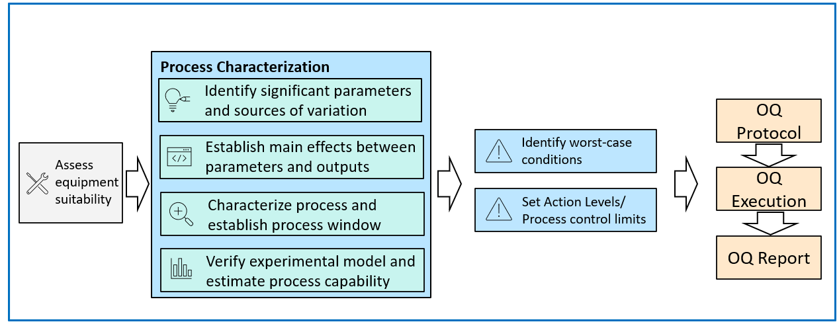
Figure 5. Typical Process Characterization and OQ activities

Measurement methods used for process characterization and OQ must be validated.

Process characterization may not be required if sufficient historical process knowledge is available, if the historic process has been proven to be in control, if the equipment qualification is documented in a validation report, and if measurements were executed with validated test methods.

OQ may not be required for manual processes or for a process with one fixed parameter which cannot or will not be adjusted during commercial manufacturing since the inherent process variation will be challenged during PQ.

Equipment Suitability
All equipment needed for the process is assessed to ensure it is suitable. For example, the IQ report of an annealing oven is checked to ensure that the equipment has been qualified for the required temperature range and temperature accuracy.

Number of required OQ runs
The number of OQ runs must correspond to the number of worst-case conditions identified. Typically, one run per worst-case condition is sufficient. It is common to identify at least two worst-case conditions. More worst-case conditions are possible if there is more than one critical quality attribute since each critical quality attribute could have its own set of worst-case conditions.

Number of manufactured samples
OQ runs must be long enough to allow the process to demonstrate its normal, common cause process variation beyond any ramp-up effects expected at start-up. The rationale for OQ run duration and the number of samples must be provided in the protocol.

Product produced during the OQ may not be made available for commercial distribution since the process is being stressed and operated under worst-case conditions which are atypical for production.

Process Characterization
21 CFR 820.70(a) states that each manufacturer shall develop, conduct, control, and monitor production processes to ensure that a device conforms to its specifications.

A successful validation program depends upon information and knowledge from product and process development. This knowledge and understanding are the basis for establishing an approach to controlling the manufacturing process that results in products that meet all requirements.

Manufacturers should:
- Understand the sources of variation.
- Detect the presence and degree of variation.
- Understand the impact of variation on the process and on product attributes.
- Control the variation in a manner commensurate with the risk it represents to the process.

Process characterization is a critical precursor to OQ, and this is where engineering runs are performed to study the process and arrive at the worst-case challenge conditions that will be challenged in OQ.

Documented evidence for critical process parameters and their respective operating limits is a required prerequisite for OQ. The following information should be known after process characterization:
- What the statistically and practically significant process parameters are. Note: These parameters are the critical process parameters.
- The main effects of the critical process parameters on the critical quality attributes.
- How interactions between process parameters affect the critical quality attributes.
- Operating limits, process control limits, and action levels for critical process parameters.
- Initial estimate of process capability for critical quality attributes.

Figure 6 shows a 6-step approach to characterizing a process in preparation for OQ, to estimate process capability, to set action limits, and to determine worst-case testing conditions.
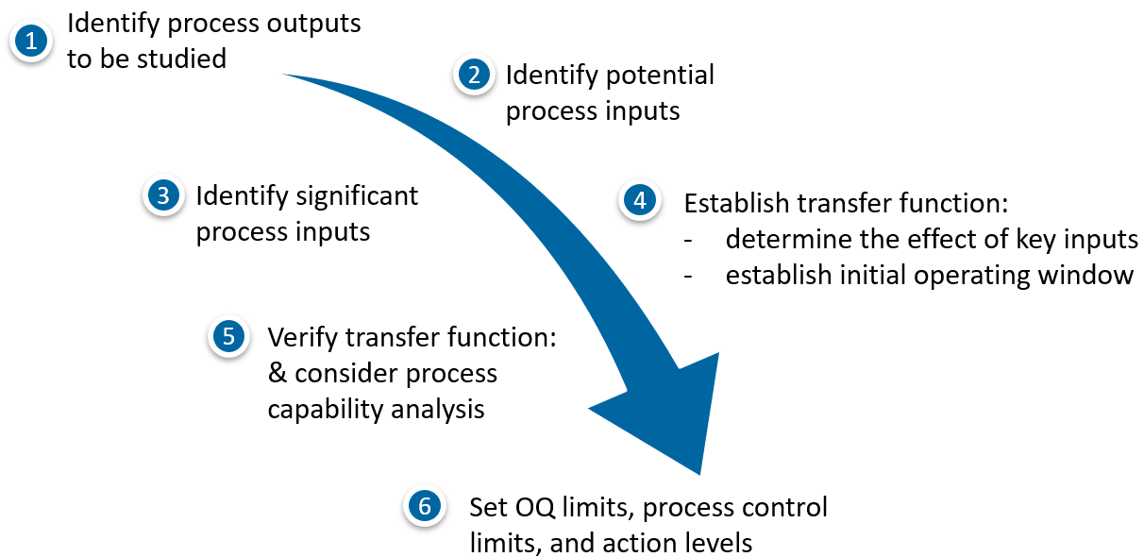
Figure 6. 6-step approach to prepare for OQ execution

Note: This section provides an overview of the activities. The details of experimentation, data analysis, and process modelling are not described here. Consult a Six Sigma Blackbelt on how to execute Design of Experiments, Data Analysis, Process Modeling, and Hypothesis Testing. The Design of Experiments methodology is described here. Other types of experiments are also acceptable.

Identify process outputs to be studied. At a minimum, all critical quality attributes should be assessed. However, other process outputs should also be assessed to gain a basic understanding of the process.

Identify potential process inputs. All process inputs should be identified. A process diagram is created to describe both controlled and uncontrolled process inputs. Brainstorming and a review of the PFMEAs are typically used to identify inputs.

Controlled inputs are equipment settings (process parameters), specified raw materials, fixtures, process operators, etc.

Uncontrolled process inputs are ambient temperature, relative humidity, and other sources of variations such as differences between received raw material or component batches, differences between duplicate equipment, differences in operator skill, etc. Robust design principles may be used during the optimizing phase to establish equipment settings which are robust to various sources of uncontrolled variation.

Identify significant process inputs. Screening studies can be performed to identify the significant process inputs. A screening study is a type of design experiment whose primary purpose is to identify significant process inputs. These experiments involve running the process at pre-planned settings and measuring the resulting process outputs.
The goal of a Process Characterization Study (PCS) is to identify process parameters that have a statistically significant impact on the critical quality attributes (CQA) of the product. Statistical significance itself does not imply that results have practical consequences. The specific Process SME should use their specialized knowledge and experience to determine whether the difference is practically significant. When a parameter is identified as statistically significant and the difference is also practically significant, this parameter is then acknowledged as a critical process parameter (CPP). CPPs are optimized during PCS, challenged in OQ, confirmed in PQ, and are monitored in routine production.

Characterize and optimize. When the critical process parameters are known, the goal is to establish an understanding of interactions between these parameters as well as their effects on the critical quality attributes. A detailed modeling experiment may be conducted to establish transfer functions. The transfer functions may be used to model the process with the intent of establishing the optimal operating window for each critical process parameter. Tools such as Minitab Response Optimizer can be used to determine the optimal set point for critical process parameters.

Verify transfer function and estimate process capability. A confirmation run should be executed to verify the validity of the experimental model (transfer functions). Enough samples should be produced and analyzed to create an initial estimate of process capability.

A hypothesis test should be completed to compare the sample mean with the predicted value from the experiment to determine if the population mean differs from the specified target.

If the hypothesis test identifies a statistically significant difference between the calculated sample mean and the predicted mean from the experimental model, the transfer functions may be invalid, and additional experiments may be necessary.

Set action levels. Action levels can be established by process engineers based on process knowledge. A better method is to establish the inherent equipment variation and to set the action limit to ± 4.5 standard deviations around the established set point. Once the process reaches the action level, an adjustment may be required to bring the process parameter closer to the nominal setpoint. Figure 7 shows the action level for a critical process parameter. The histogram represents common cause equipment variation. The action level alerts the process operator before equipment drifts outside of the qualified operating window.

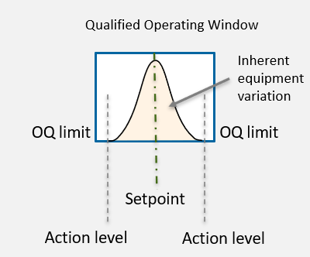
Figure 7. Schematic depiction of an action level

Test results of process characterization studies must be documented and controlled to provide evidence and underpinning for the operating limits that will be challenged in OQ, confirmed in PQ, and used for the commercial manufacturing process.

OQ Prerequisites
The following activities need to be completed before the OQ protocol is executed:

Unless there is sufficient historic data available the process must be characterized before the OQ protocol is written. Results must be documented in an approved test report.

Equipment, tools, and fixtures used for building OQ samples must be production equivalent and must have an approved installation qualification report. The same equipment must be used for the OQ as is used in production.

The materials used for the build (raw material, parts, sub-assemblies) must be qualified.

TMV reports must be approved for the tests, inspections, and measurements executed as part of the OQ study.

Software validation must be completed for all custom software.

The initial risk assessment portion of the Process FMEA is complete and approved. Severity levels for quality and safety product characteristics have been communicated by Philips in the SRPQP.

The process operators, technicians, inspectors, and engineers participating in the execution of the OQ are trained to the OQ protocol and associated procedures.

The process operators are qualified to perform the actual manufacturing process. Qualification should include more than reading and understanding a work instruction.

As applicable, process operators and inspectors must be certified to international standards.

The process validation plan is approved as applicable (if PVP is required per vendor QMS).

The initial Device Manufacturing Record (DMR) is controlled.

The OQ protocol is approved.

Worst-Case Definition
Worst-case testing is a key aspect of operational qualification for medical devices. Worst case testing involves running the equipment or process at the upper or lower operating limits, or a combination thereof. The purpose is to challenge the equipment or process to ensure that the product meets predetermined requirements even when the equipment runs at the extreme conditions.

Failure is not expected during OQ because the operating window was originally established such that the process produces products that meets specifications if the process inputs are operated within that range.

OQ Protocol
The following elements should be included in the OQ protocol.

Purpose. The following is an example of an OQ purpose statement:
The purpose of this Operational Qualification (OQ) is to demonstrate by objective evidence that the XXX process produces products that meet all pre-determined requirements under the worst-case conditions of manufacturing.

Scope. Provides details on what is covered in the specific OQ including but not limited to:

Location of the process being validated.

Part, element (sub-assembly), or product/system (10NC/12NC/6NC) that is made with the process to be validated.

Manufacturing process name or ID.

Acronyms and Definitions. All acronyms and process specific terminology should be defined in this section.

Responsibilities. This section is optional. It describes the responsibilities for the OQ study. Note: Employee names or ID numbers are not listed in the protocol.

Background. This section is optional but highly recommended. It explains to the unfamiliar reader what the OQ is about. It can be used to provide a brief description of the product being made and the process being validated. A summary can be provided to explain how the significant process inputs were determined, how their set points, operating limits, and action levels were established during process characterization. The supplier and its relationship with Philips can also be described here.

Protocol Training and Defect Awareness Training for Validation. All personnel executing any part of the OQ protocol must be trained prior to the execution. Training of the protocol content and associated work instructions must be completed. Training records must be established and attached to the OQ report. Personnel is trained after the protocol is approved but before it is executed. The dated and signed training form provides the objective evidence that training was executed before the protocol was executed.

Operator qualification and certification: Process operators building the OQ samples should be the same operators who will build the product during commercial manufacturing. The process operators should be qualified and if required certified before the OQ commences. For example, welding operators and weld inspectors should be certified to an ISO standard. If certification is required, only certified operators may perform the welding and inspection of OQ samples.

Deviations from the Protocol. When deviations from the protocol occur during execution, the protocol must be redlined and signed for approval by designated individuals before continuing with the execution. A rationale must be provided with each redline. If a deviation is not discovered until the data is being analyzed, a rationale must be provided in the OQ report why the deviation is acceptable.

An acceptable deviation is an administrative deviation where an inspector uses an outdated form but collects all required data.

An example of an unacceptable deviation is when the inspector used different measurement/test method than specified in the protocol to inspect OQ samples.

Process Condition
Critical Quality Attributes (CQAs). Describe the critical quality attributes that are tested with the OQ. Table 3 shows an example of the information to be included.

- CQA | - Specification | - Source | - Classification/  - Severity ^{[1]} | - Data Type | - Confidence/  - Reliability ^{[1]} | - Sample Size | - Measurement Method
- Length | - 100mm ± 2mm | - Drawing XZY, Rev 2 | - CTQ-S1 | - Variable | - 95% C  - 90% R | - 15 per OQ run | - Digital Calipers (0-150mm)
Table 3: CQA Example 1
^{[1]}Classification/Severity and Confidence Reliability should be provided by Philips in accordance with the sampling plans described in this guideline.

Critical Process Parameters (CPPs). Describe the critical process parameters that are challenged with the OQ study. Two tables are recommended. The first table lists the inputs and their respective operating ranges.
- CPP | - Low Operating Limit | - Nominal Setting | - High Operating Limit
- Seal Temperature | - 130°C | - 140°C | - 150°C
- Dwell Time | - 1.0 sec | - 1.25 sec. | - 1.5 sec
- Cool Time | - 2 sec | - 3 sec | - 4 sec
- Pressure | - 50 Psi | - 55 Psi | - 60 Psi
Table 4: Example of CQA Summary Table
The second table describes the worst-case challenge conditions (OQ 1 and OQ 2, sometimes also described as OQ high and OQ low)
CPP | OQ 1 | OQ 2
Seal Temperature | 130°C | 150°C
Dwell Time | - sec | 1.5 sec.
Cool Time | 4 sec | 2 sec
Pressure | 50 Psi | 60 Psi
Table 5: Example of Worst-Case Process Settings
An explanation should be provided why the presented OQ 1 and OQ 2 conditions are the worst case for the product being made.

Controlled work instructions may be referenced in the protocol to describe the settings for all non-critical process parameters. If draft work instructions are used, they must be attached to the protocol.

Actual values for critical process parameters must be monitored during OQ run execution. The Set-points and actual value should be documented at least at the beginning, middle, and the end of each OQ run.

Build Requirements. This chapter describes the following:

Equipment. Document a list of equipment, tooling, and fixtures that will be used to build the OQ samples. It is a CDRH expectation that the equipment used during validation is documented. Only qualified equipment, tooling, and fixtures may be used for OQ. The same equipment that will be used for commercial manufacturing must be used for OQ.

Work Instructions. The OQ protocol must include a complete list of work instructions that will control the manufacture of OQ samples. The same work instructions that will be used for commercial manufacturing need to be used for OQ. The work instructions should be complete, approved, and referenced in the protocol by title and document number. It is acceptable to use draft work instructions if they are attached to the OQ protocol for traceability instead.

Build Parameters. Details and background of the OQ runs including rationales are described for:
- the number of samples that are manufactured/assembled/built for each OQ run.
- the number of operators that will be used.
- the number of raw material lots or component lots that will be used.
- during which production shift the OQs will be built.
It is acceptable to build OQ runs with one operator, one equipment, one material lot because worst-case conditions are challenged. Commercial production is not expected to run under these conditions. Sources of variation are challenged in the PQ.

Build Execution. Describe the process conditions for each OQ run in this chapter. This should tell the process operators how to set up the equipment for each OQ and how many samples to build per OQ run. Work instructions should describe how to build the OQ samples. There may be some additional requirements for an OQ run which is not part of routine or commercial manufacturing. For instance, during commercial manufacturing, a machine may be cleaned once a week but for OQ it is decided to clean the machine before each OQ run. This would be a special build instruction, which needs to be documented in the protocol.

Sample Conditioning. As applicable, the samples may need to be conditioned per the specifications before they are tested. For instance, devices may need to be sterilized before they are tested.

Inspection and Testing of OQ Samples. For each CQA, provide the information presented in this chapter.

Sample Size Rationale: A rationale for the number of test samples must be provided in the protocol. The rationale must be based on valid statistical techniques. Sample size depends on the CQA classification (CTQ, CTS, KPI) and the associated Severity of Harm (SOH) or Severity of Effect (SOE). Criticality classification, SOH, and SOE must be provided by Philips. Refer to chapter 10 for a list of sampling plans that are based on valid statistical techniques.

A sample size rationale in a supplier’s protocol may be worded like the following:

Example for OQ protocol, attribute data, CTS-S4:

‘‘Sampling plans will be used to make a pass/fail decision for each requirement. The proposed sampling plan is provided by Philips Healthcare in the signed SRPQP (Document Reference) For a CQA with classification CTS and SOH S4, an attribute sampling plan is selected that provides 95% confidence that at least 95% of products conform to requirements at all anticipated conditions of manufacturing (worst-case). A sampling plan with n=59 and c=0 meets this requirement whereas n=number of samples to be tested and c=maximum number of failures allowed. 59 samples will be collected for testing from each OQ run.”

Example for OQ protocol, variable data with two-sided specification, CTS-S4:

‘‘Sampling plans will be used to make a pass/fail decision for each requirement. The proposed sampling plan is provided by Philips Healthcare in the signed SRPQP (Document Reference). For a CQA with classification CTS and SOH S4, a variable sampling plan is selected that provides 95% confidence that at least 95% of products conform to requirements at all anticipated conditions of manufacturing (worst-case). A sampling plan for a two-sided specification with n=15 and RQL = 5% is selected. 15 samples will be collected for testing from each OQ run. The sampling plan will accept the OQ run if the calculated Ppk of the 15 samples is equal to or greater than 0.87 and if the calculated Pp of the 15 samples is equal to or greater than 0.91. Data will be tested for normality before analysis. If the normality test fails, a suitable distribution will be determined for the analysis, or data may be converted to attribute data.”

Sample collection strategy. The protocol describes how test samples are collected during or after the sample builds. Some but not all sampling strategies are:
- Random selection of test samples during manufacturing or from the finished OQ run. This is only recommended for attribute data. For variable data, this sample collection approach does not provide an adequate picture of process behavior from beginning to end of the OQ run.
- Periodic sampling where every n^{th} unit is selected. For instance, if 30 samples are made per OQ run, and 15 test samples are required, one could collect every 2nd unit.
- Stratified sampling where an equal number of samples is selected from a subset of the manufactured OQ run. For example, 30 samples are made, and the samples are collected in 15 tote pans with 2 units per tote pan. One sample per tote pan is selected randomly to obtain 15 test samples per OQ run.
If multiple products are produced simultaneously, for instance in a multi-cavity mold for injection molding, product from each cavity should be measured to provide objective evidence that products are equivalent regardless of cavity. Alternatively, equivalence can be established and demonstrated during process characterization. If cavities are shown to be equivalent, random samples from all cavities can be collected for OQ.
Collected samples must be identified for traceability and stored in an orderly fashion. This step is crucial especially if there is a need to reinspect samples.

Test Plan. Describe the test plan. Test samples may be used for more than one test or inspection. For instance, samples could be visually inspected, then measured, and after that destructively tested. The protocol should detail the test sequence and provide a rationale for why it is acceptable to use the same samples for multiple tests.
- Each inspection/measurement/test is described in detail. This includes documenting a work instruction for executing the test or alternatively describing the test procedure in the OQ protocol itself.
- All measurements and tests must have evidence of test method validation before the OQ protocol execution begins.
- All measurement equipment used for testing OQ samples must be qualified.

Data Analysis. The data analysis method is documented in the protocol.

Attribute data does not require an analysis. The number of test failures are counted, and if the number of failures is equal or smaller than what the sampling plan allows, the study passes. Otherwise, the study fails. The default sampling plans in this guideline for OQ allow 0 failures. Therefore, even one failure results in a failing OQ.

Variable sampling plans require that data follow the normal distribution. Therefore, data must be tested for normality before the analysis continues. Ppk and Pp values may only be calculated if data is normal. If the normality test fails, the reason for nonnormality must be investigated. Refer to chapter 13 for guidance on testing normality with Minitab software,

If the normality test passes, calculate sample mean and sample standard deviation, and follow the calculations presented in chapter 11 for each sampling plan. Compare the calculated Ppk and Pp values to the sampling plan’s criteria. If the calculated Ppk/Pp values are equal to or greater than the sampling plan’s criteria, the requirement for the process output is met.

Disposition of Materials: Describe how the materials that are used to build OQ samples and the OQ samples are dispositioned. OQ samples are typically not released for commercial sales.

Disposition of Deviations (report only). Each deviation from the protocol must be addressed in the report. A rationale is provided for each deviation explaining why the deviation is acceptable. If the deviation is not acceptable, the OQ study fails.

Conclusion (report only). The conclusion is provided in the OQ report. Conclusion is either pass or fail. The OQ study fails if one or more deviations are not accepted or if any of the acceptance criteria or requirements are not met. Every OQ test must meet the respective acceptance criteria.

Confidence and Reliability Statement. The OQ report must include a Confidence and Reliability Statement. An example of such a statement is shown in chapter 10.5.

Performance Qualification (PQ)
PQ is the final stage of process validation. The GHTF guidance [Ref-1] defines PQ as establishing by objective evidence that the process, under anticipated conditions, consistently produces a product which meets all predetermined requirements.

The MDSAP audit approach [Ref-3] states that data are required to demonstrates that predetermined specifications were met consistently. This involves running multiple PQ runs.

Data collected during the PQ study must demonstrate not only that the PQ runs are meeting requirements but also that all future production runs will meet requirements. This requires that PQ runs are executed to represent future production runs. To do so, the PQ runs must simulate the range of conditions that will be encountered during routine manufacturing. The range of conditions may include but is not limited to:
- Variation between different raw material and part/component/subassembly batches.
- Variation between production shifts.
- Variation between (duplicate) equipment, tooling, and fixtures.
- Variation from equipment setups and changeovers.
- Variation between process operators (due to varying sill levels and aptitudes).
- Variations in environmental conditions (e.g., lighting, ambient temperature, humidity), etc.

The PQ runs should confirm the documented and approved range of conditions defined by the various control limits and action levels established during OQ. The process outputs should be consistent, and the process should be predictable regardless of the manufacturing condition.

Nominal Setpoint versus Normal Operating Range
Some critical process parameters run at nominal setpoints while others operate at a range. A range may be required for one critical process input to compensate for the variation of another critical process input. Some examples are discussed below.

A critical process parameter operating at a set point means that the process parameter always runs at the same setpoint, and the process operator is not allowed to adjust the parameter during the run or from one run to the next. All PQ runs are executed at the respective setpoint. Although the parameter runs at a setpoint the displayed value may vary due to common cause variation. For instance, the temperature may be set to 90°C and the display may vary from 88°C to 92°C. The variation around the setpoint must be within the qualified operating range (OQ limits) of the process parameter.

A critical process parameter operating at a range means that the process parameter is adjusted before or during a run within a qualified range. For example, the seal temperature in a sterile packaging process may require an adjustment within a qualified range to compensate for varying material thickness of the packaging material. During set up, the thickness of the packaging material is measured, and the appropriate temperature is used. The relationship between material thickness and seal temperature is established and confirmed during process characterization.

Number of required PQ runs
Enough PQ runs should be completed to ensure the anticipated conditions (sources of variation) are represented, the results are meaningful and consistent, and to demonstrate that the process is repeatable and reproducible. Regardless of other conditions, at least 3 PQ runs should be completed.

The requirement for 3 PQ runs is described in the GMP’s Preamble [Ref-5], Federal Register. Vol. 61, No 195, page 52621 where the following statement is made:
The requirement for testing from the first three production lots or batches has been deleted. While FDA believes that three production runs during process validation (process validation may be initiated before or during design transfer) is the accepted standard, FDA recognizes that all processes may not be defined in terms of lots or batches. The number three is, however, currently considered to be the acceptable standard. Therefore, although the number requirement is deleted, FDA expects validation to be carried out properly in accordance with accepted standards and will inspect for compliance accordingly.

The PQ study is planned to include multiple operators, multiple batches of raw materials or components as applicable, multiple equipment as applicable, multiple shifts, etc. distributed over the PQ runs. When multiple, duplicate equipment is used, at least one PQ run per piece of equipment should be completed. Note: This is not a repeat of the designed experiments during process characterization. Different equipment, operators, and material lots are assigned randomly to each PQ run. PQ is a confirmation of already established process conditions.

It is an expectation of CDRH that a rationale for the number of PQ runs is included in the PQ protocol.

Number of manufactured samples
Valid statistical techniques require that collected samples are representative of the population (future manufactured product). It is therefore required to manufacture enough samples during a PQ run to capture the common cause variation one would expect during routine production. Only then will the test samples be representative of future products. One method to achieve this is by running a typical manufacturing lot size for each PQ run. If that is not feasible, PQ runs may be shorter than a typical manufacturing lot, if the common cause variation of the process is captured.

Highly manual processes for instance may be shortened unless operator fatigue is challenged during PQ. A rationale for the number of manufactured samples must be documented in the PQ protocol.

PQ Prerequisites
The following activities need to be completed before the PQ protocol is executed.

Equipment, tools, and fixtures that are used for building PQ samples must be production equivalent and must have an approved installation qualification report.

The materials used for the build (raw material, parts, sub-assemblies) must be qualified.

TMV reports must be approved for all tests, inspections, and measurements executed as part of the PQ study.

Software validation must be completed for all custom software.

The initial risk assessment portion of the Process FMEA is complete and approved. Severity levels for quality and safety product characteristics are established and have been communicated by Philips.

The process operators, technicians, inspectors, and engineers participating in the execution of the PQ are trained to the PQ protocol and all associated work instructions and procedures.

The process operators are qualified to perform the actual manufacturing process. As applicable, process operators and inspectors are certified.

OQ Report: some companies require that the OQ report is approved before PQ commences, other companies allow the OQ and PQ to run in parallel. Both options are acceptable. The supplier is to follow their internal procedure.

The Device Manufacturing Record (DMR) or Medical Device File (MDF) is approved including work and inspection instructions (may include redlines approved as PQ protocol attachment).

PQ builds are not started until the PQ protocol is approved.

The manufacturing control plan has been approved.

Protocol
The following elements should be included in the PQ protocol.

Purpose. The following is an example of a PQ purpose statement:
The purpose of this Performance Qualification (PQ) is to demonstrate by objective evidence that the XXX process under normal conditions of manufacturing consistently produces products that meet all pre-determined requirements.

Scope. Provides details on what is covered in the specific PQ including but not limited to

Location of the process being validated.

Part, sub-assembly, or product/system (10NC / 12NC / 6NC) that is made with the process to be validated.

Manufacturing process name or ID.

Acronyms and Definitions. All acronyms and process specific terminology should be defined in this section.

Responsibilities. This section is optional. It describes the responsibilities for the PQ study. Note: Employee names or ID numbers are not listed in this chapter.

Background. This section is optional but highly recommended. It explains to the unfamiliar reader what the PQ is about. It can be used to provide a brief description of the product being made and the process being validated. A summary can be provided to explain how the significant process inputs were determined, how their set points, operating limits, and action levels were established during process characterization. The supplier and its relationship with Philips can also be described here.

Protocol Training and Defect Awareness Training for Validation. All personnel executing any part of the PQ protocol must be trained prior to the execution to the protocol and required work instructions. Training records must be established and attached to the PQ report. Operator qualification and certification: Process operators building the PQ samples should be the same operators who will build the product during commercial manufacturing. The process operators must be qualified and if required certified before the PQ commences. For example, welding operators should be certified to an ISO standard. In that case, only certified operators may perform the welding of PQ samples.

Deviations from the Protocol. When deviations from the protocol occur during execution, the protocol must be redlined and signed for approval by designated individuals before continuing with the execution. A rationale must be provided with the redline. If a deviation is not discovered until the data is being analyzed, a rationale must be provided in the PQ report why the deviation is acceptable.

An acceptable deviation is an administrative deviation where an inspector uses an outdated form but collects all required data.

An example of an unacceptable deviation is when the inspector used different measurement/test method than specified in the protocol to inspect PQ samples.

Process Conditions
Critical Quality Attributes (CQAs). Describe the critical quality attributes that are tested with the PQ. The table below shows an example of the information to be included.

- CQA | - Specification | - Source | - Classification/  - Severity ^{[1]} | - Data Type | - Confidence/  - Reliability ^{[1]} | - Sample Size | - Measurement Method
- Length | - 100mm ± 2mm | - Drawing XZY, Rev 2 | - CTQ-S1 | - Variable | - 95% C  - 90% R | - 15 per OQ run | - Digital Calipers (0-150mm)
Table 6: CQA Example 2
^{[1]}Classification/Severity and Confidence Reliability should be provided by Philips in accordance with the sampling plans described in this guideline.

Critical Process Parameters (CPPs). Describe the critical process parameters that are confirmed with the PQ study. Two tables are recommended. The first table lists the inputs and the respective operating ranges.

- CPP | - Low Operating Limit | - Nominal Setting | - High Operating Limit
- Seal Temperature | - 130°C | - 140°C | - 150°C
- Dwell Time | - 1.0 sec | - 1.25 sec. | - 1.5 sec
- Cool Time | - 2 sec | - 3 sec | - 4 sec
- Pressure | - 50 Psi | - 55 Psi | - 60 Psi
Table 7: Example of CPP Table
The second table describes the conditions for each PQ run.
- CPP | - PQ 1 | - PQ 2 | - PQ 3
- Seal Temperature | - 140°C | - 140°C | - 140°C
- Dwell Time | - 1.25 sec | - 1.25 sec. | - 1.25 sec
- Cool Time | - 3 sec | - 3 sec | - 3 sec
- Pressure | - 55 Psi | - 55 Psi | - 55 PSI
Table 8: Example of CPPs for PQ Study

Build Requirements. This chapter describes the following:

Equipment. Document a list of equipment, tooling, and fixtures that will be used to build the PQ samples. It is a CDRH expectation that the equipment used during validation is documented. Only qualified equipment, tooling, and fixtures may be used for PQ. Use the same equipment, tooling, and fixtures that were used for OQ and that will be used for commercial manufacturing.

Work Instructions. Include a complete list of work instructions that will control the building of PQ samples. Use the same work instructions that will be used for commercial manufacturing. The work instructions must be complete, approved, and referenced in the protocol by title and document number. One exception to this rule is when a change is made to an existing process. In this case, the work instruction is redlined and attached to the protocol.

Build Parameters. Describe details and background of the PQ runs including rationales for the number of PQ runs and the number of samples that are built with each PQ run.
- The number of PQ runs that will be executed including a rationale.
- The number of samples that are manufactured/assembled/built for each PQ run.
- The number of process operators that will build the PQ samples.
- The number of raw material lots or component lots that will be used for the PQ builds
- During which production shift the PQs will be built.
Before writing the PQ protocol, determine the sources of variations in the anticipated commercial manufacturing environment and design the PQ study so that the uncontrolled significant sources of variation are included in the PQ study. Consider differences in process operator skill, variances between equipment, differences between incoming materials and parts, differences between shifts, etc.
Randomize the different sources of variation over the number of PQ runs. Although 3 PQ runs is the accepted industry practice, more PQ runs may be necessary to challenge all sources of variation.

Build Execution. Describe the process conditions for each PQ run in this chapter. This should tell the process operators how to set up the equipment for each PQ and how many samples to build per PQ run. Work instructions describe how to build the PQ samples. There may be some additional requirements for a PQ build which is not part of routine or commercial manufacturing.

Sample Conditioning. As applicable, the samples may need to be conditioned per the specifications before they are tested. For instance, devices may need to be sterilized before they are tested.

Inspection and Testing of PQ Samples. For each CQA, provide the information presented in this chapter.

Sample size determination. A rationale for the number of test samples must be provided in the protocol. The rationale must be based on valid statistical techniques. Sample size depends on the CQA classification (CTQ, CTS, KPI) and the associated Severity of Harm (SOH) or Severity of Effect (SOE). Criticality, SOH, and SOE must be provided by Philips. Refer to chapter 10 for a list of sampling plans which are based on valid statistical techniques.
A sample size rationale example in a supplier’s protocol may be worded like the following:
Example for PQ protocol, attribute data, CTS-S4:
‘‘Sampling plans will be used to make pass/fail decision for each requirement. The proposed sampling plan is provided by Philips Healthcare in the signed SRPQP (Doc Reference). For a CQA with CTS and SOH S4, an attribute sampling plan is selected that provides 95% confidence that at least 99% of products conform to requirements at normal conditions of manufacturing. A sampling plan with n=299 and c=0 meets this requirement whereas n=number of samples to be tested and c=maximum number of failures allowed. The samples will be pooled over the PQ runs. Therefore, 100 samples each will be collected for testing from PQ run 1 and 2, and 99 samples will be collected for testing from PQ run 3.”

Example for PQ protocol, variable data with two-sided specification, CTS-S4:
‘‘Sampling plans will be used to make pass/fail decision for each requirement. The proposed sampling plan is provided by Philips Healthcare in the signed SRPQP (Doc Reference). For a CQA with classification CTS and SOH S4, a variable sampling plan is selected that provides 95% confidence that at least 99% of the components meet requirements under normal conditions of manufacturing. A sampling plan for a two-sided specification with n=15 and RQL = 1% is selected. 15 samples per PQ run will be collected for testing. The sampling plan will accept the PQ run if the calculated Ppk of the 15 samples is equal to or greater than 1.18 and if the calculated Pp of the 15 samples is equal to or greater than 1.18. Data will be tested for normality before analysis. If the normality test fails, a suitable distribution will be determined for the analysis, or data may be converted to attribute data.”

Sample collection strategy. The protocol describes how test samples are collected during or after the sample builds. Some but not all sampling strategies are:
- Random selection of test samples during manufacturing or from the finished PQ run. This is only recommended for attribute data. For variable data, this sample collection approach does not provide an adequate picture of process behavior from beginning to end of the PQ run.
- Periodic sampling where every n^{th} unit is selected. For instance, if 30 samples are made per PQ run, and 15 test samples are required, one could collect every 2nd unit.
- Stratified sampling where an equal number of samples is selected from a subset of the manufactured PQ run. For example, 30 samples are made, and the samples are collected in 15 tote pans with 2 units per tote pan. One sample per tote pan is selected randomly to obtain 15 test samples per PQ run.
If multiple products are produced simultaneously, for instance in a multi-cavity mold for injection molding, product from each cavity should be measured to provide objective evidence that products are equivalent regardless of cavity. Alternatively, equivalence can be established and demonstrated during process characterization. If cavities are shown to be equivalent, random samples from all cavities can be collected for PQ.
Collected samples must be identified for traceability and stored in an orderly fashion. This step is crucial especially if there is a need to reinspect samples.

Test Plan. Describe the test plan. Test samples may be used for more than one test or inspection. For instance, samples could be visually inspected, then measured, and after that destructively tested. The protocol should detail the test sequence and provide a rationale for why it is acceptable to use the same samples for multiple tests.
- Each inspection/measurement/test is described in detail. This includes documenting a work instruction for executing the test or alternatively describing the test procedure in the PQ protocol itself.
- All measurements and tests must have evidence of test method validation before the PQ protocol execution begins.
- All measurement equipment used in the testing of PQ samples must be qualified.

Data Analysis. The data analysis method is documented in the protocol.

Attribute data does not require an analysis. The number of test failures are counted, and if the number of failures is greater than what the sampling plan allows, the study fails. Otherwise, the study passes. The default sampling plans in this guideline for PQ allow 0 failures. Therefore, even one failure results in a failing PQ.

Variable sampling plans require that data follow the normal distribution. Therefore, data must be tested for normality. If the normality test fails, the reason for nonnormality must be investigated. Refer to chapter 13 for guidance on testing normality with Minitab.

If the normality test passes, calculate sample mean and sample standard deviation and follow the calculations presented in chapter 11 for each sampling plan. Compare the calculated Ppk and Pp values to the sampling plan’s criteria. If the calculated Ppk/Pp values are equal to or greater than the sampling plan’s criteria, the requirement for the process output is met.

Disposition of Materials: Describe how the materials that are used to build PQ samples and the PQ samples are dispositioned. PQ samples may be used for design verification or design validation testing or may be released for commercial sale after the process validation meets validation requirements and product release criteria, and after the PQ report is approved.

Disposition of Deviations (report only). Each deviation from the protocol must be addressed in the report. A rationale is provided for each deviation explaining why the deviation is acceptable. If the deviation is not acceptable, the PQ study fails.

Conclusion (report only). The conclusion is provided in the PQ report. Conclusion is either pass or fail. The PQ study fails if one or more deviations are not accepted or if any of the acceptance criteria or requirements are not met. At least three consecutive PQ runs must pass for the PQ study to pass. Each executed test must meet acceptance criteria and predetermined specifications.

Test Method Validation
Test method validation is required for acceptance activities for process validation as outlined below. The same test methods must be used for process validation and routine production.

Measurement variation caused by the measurement process can result in the release of non-conforming products and must be reduced to an acceptable level. Common sources of variation are shown in the image below. Measurement variation consists of precision and accuracy errors. Figure 8 shows the typical sources of measurement variation.

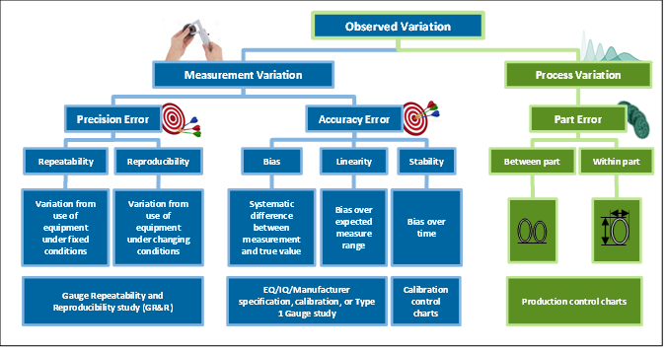
Figure 8: Sources of measurement variation. Accuracy Error is typically represented by the bias established during calibration.
Test methods used for process characterization, OQ, and PQ must be validated. Inspections of non-CQAs during process characterization, OQ, and PQ do not require TMV but measurement instruments with an Accuracy to Tolerance ratio of 25 or less must be used.

For more information on TMV execution refer to the global Test Method Validation Procedure.

Sampling Plans for Process Validation
Operational Qualification (OQ) and Performance Qualification (PQ) are confirmatory studies that make pass/fail decisions on whether each requirement is met. This requires the use of sampling plans. When demonstrating that requirements are met, the appropriate statistical property should be used. In this guideline, the statistical property “Proportion Conforming” is described.

Risk-Based Sampling Plans
Sampling plans are risk-based meaning that the required Proportion Conforming increases as the Severity of Harm (SOH) or Severity of Effect (SOE) for a quality attribute increase.

Sampling Plan Assumptions
Sampling plans must be based on valid statistical techniques per 21CFR 820.250 (b). Therefore, the following assumptions must be met when using sampling plans for process validation:

Samples collected from OQ and PQ runs are representative samples. A representative sample is one that does not systematically differ from other samples built during the OQ or PQ runs.

Samples collected for testing against requirements must be representative of the entire population, meaning the future products made. Therefore, OQ and PQ runs must run long enough or produce enough parts/products to capture the normal (common cause) process variation that is expected in routine production.

For PQ, the product should be produced under all anticipated conditions of (future) routine manufacturing.

Variable sampling plans assume that the test data follow the normal distribution. Therefore, a normality test must be performed before analyzing variable data. Refer to chapter 13 for an example of a normality test.

Confidence and Reliability

95% Confidence will be used for all variable and attribute Philips sampling plans unless otherwise stated in this guideline.

For visual inspections, 90% confidence can be used when multiple CQAs are inspected at once, meaning a unit is nonconforming if it has one or more visual defect types.

The ‘Proportion Conforming’ is validated to meet the levels of Table 9 which are based on risk levels defined in the Philips Risk Management process. Percent conforming is equivalent to the percent reliability of the process.

Criticality, Severity of Harm (SOH), Severity of Effect (SOE) ^{[1]} | PQ  (Reliability) | OQ  (Reliability) ^{[2]}
CTS-S4 | 99% | 95%
CTS-S3 | 97% | 93.5%
CTS-S2  CTQ-SEV8  CTQ-S | 95% | 90%
CTQ-SEV5 | 93.5% | 85%
CTQ-SEV3  CTQ-SEV1  Key Process Indicator | 90% | 80%
Non-CTS-S2  Non-CTS-S1  Non-CTS-S0  Non-CTQ SEV8  Non-CTQ SEV5  Non-CTQ SEV3  Non-CTQ SEV1 | No Sampling Plan  n=1 per PQ run | No Sampling Plan  n=1 per OQ run
Table 9: Reliability Levels for PQ and OQ
^{[1]} As gathered from Philips drawings, Philips Design FMEA documents, etc.
^{[2]} OQ runs are executed at worst-case conditions, making them stress tests. Stress tests can be validated to reduced reliability levels because tests at these conditions induce a higher level of non-conforming units than tests at normal manufacturing conditions [paraphrased from Reference 2, Stat-03, Page 8].

Sampling Plan Rationales
A rationale for the selected sampling plan must be documented in each OQ and PQ protocols.

For each CQA that is tested in the validation study, the highest Criticality, Severity of Harm, or Severity of Effect is determined (see Table 9), and the respective sampling plan from this procedure is selected. Note that each CQA may have its own sampling plan.

For critical quality characteristics that are marked as CTS and do not have any information regarding the Severity of Harm, the sampling plan for CTS-S4 must be used.

For critical quality characteristics that are marked as CTQ and do not have any further information regarding the Severity of Effect, the sampling plan for CTS-SEV 8 must be used.

Sampling Plan Confidence and Reliability Statement

Confidence statements about process performance must be included in every OQ and PQ report. Each tested CQA requires a separate confidence statement. An example of a confidence statement is: With 95% confidence, more than X% of units conform to requirements. X is the % Reliability based on criticality, SOH and SOE from Table 9.
No | Condition | Confidence Statement
1 | OQ run with CQA of CTS-S3 passes the test. | With 95% confidence, more than 93.5% of products conform to requirements when produced at worst-case manufacturing conditions.
2 | PQ run with CQA of CTS-S3 passes the test. | With 95% confidence, more than 97% of products conform to requirements when produced under normal manufacturing conditions.
Tabel 10: Examples of Confidence Statements

Note: These confidence statements describe an unacceptable level of performance which is rejected by the sampling plan most of the time. The statement “With 95% confidence, more than 97% or product conforms” means that 97% is an unacceptable performance level that the sampling plan rejects most of the time. To pass the associated sampling plan, the percent conformance must be significantly better than 97%, more like 99.9%.

Attribute sampling plans for 95% Confidence
Use the sampling plans in Table 11 for all attribute pass/fail decisions unless a visual inspection of two or more CQAs is made. For the latter, use Table 12.

Criticality,  Severity of Harm (SOH), Severity of Effect (SOE) | PQ |  |  |  | OQ
 | Reliability ^{[3]} | Sample Size ^{[6]} | RQL ^{[4]} | AQL ^{[5]} | Reliability ^{[3]} | Sample Size ^{[6]} | RQL ^{[4]} | AQL ^{[5]}
CTS-S4^{[1]} | 99% | n=299  c=0 | 1% | 0.017% | 95% | n=59  c=0 | 5% | 0.086%
CTS-S3^{[1]} | 97% | n=99  c=0 | 3% | 0.051% | 93.5% | n=45  c=0 | 6.5% | 0.11%
CTS-S2^{[1]}  CTQ-SEV8^{[2]}  CTQ-S | 95% | n=59  c=0 | 5% | 0.086% | 90% | n=29  c=0 | 10% | 0.17%
CTQ-SEV5^{[2]} | 93.5% | n=45  c=0 | 6.5% | 0.11% | 85% | n=19  c=0 | 15% | 0.26%
CTQ-SEV3^{[2]}  CTQ-SEV1^{[2]}  Key Process Indicator | 90% | n=29  c=0 | 10% | 0.17% | 80% | n=14  c=0 | 20% | 0.36%
Non-CTS-S2  Non-CTS-S1  Non-CTS-S0  Non-CTQ SEV8  Non-CTQ SEV5  Non-CTQ SEV3  Non-CTQ SEV1 | No Sampling Plan  n=1 per PQ run |  |  |  | No Sampling Plan  n=1 per OQ run
Note [1]: When a critical quality attribute (CQA) is classified as a CTS (e.g., on a drawing) and there is no severity of harm (SOH) information available in a Philips FMEA document, the sampling plan for CTS-S4 shall be used.
Note [2]: When a critical quality attribute (CQA) is classified as a CTQ (e.g., on a drawing) and there is no severity of effect (SOE) information available in a Philips FMEA document, the sampling plan for CTQ-SEV8 shall be used.
Note [3]: The reliability is the percentage or proportion conforming. The reliability level is risk-based.
Note [4]: The RQL is the Reject Quality Level. RQL = 100% - % Reliability. The RQL is representative of the percentage or proportion nonconforming that the sampling plan rejects on a regular basis.
Note [5]: The AQL is the Accept Quality Level. The AQL is representative of the percent or proportion nonconforming that the sampling plan accepts on a regular basis. Note: It is not a requirement to meet the AQL. The AQL is merely presented for reference. The % in this column indicates the estimated defect rate the process should have for the sampling plan to accept the OQ or PQ run on a routine basis (95% of the time). Defect rates can be estimated based on similar processes with historic data or test results from process characterization, engineering runs, pilot builds, etc.
Note [6]: n is the number of samples to be tested, and c is the number of failures allowed. If the actual failure rate is greater than c (c=0 for all attribute sampling plans) the validation study fails. For PQ the required sample size may be pooled over all PQ runs but for OQ the sample size is for each worst-case condition or each OQ run.
Table 11: Risk-based Attribute sampling plans. 95% Confidence, α=5%, ß=5%.

Attribute sampling plans for 90% Confidence
Attribute sampling plans described in Table 12 are only allowed for visual inspections when two or more defects are inspected at the same time, meaning the part, element, or product could have two or more failure types. 90% confidence is acceptable for this type of inspection because defects are detected with fewer samples.

Criticality,  Severity of Harm (SOH), Severity of Effect (SOE) | PQ |  |  |  | OQ
 | Reliability ^{[3]} | Sample Size ^{[6]} | RQL ^{[4]} | AQL ^{[5]} | Reliability ^{[3]} | Sample Size ^{[6]} | RQL ^{[4]} | AQL ^{[5]}
CTS-S4^{[1]} | 99% | n=230  c=0 | 1% | 0.022% | 95% | n=45  c=0 | 5% | 0.11%
CTS-S3^{[1]} | 97% | n=76  c=0 | 3% | 0.067% | 93.5% | n=35  c=0 | 6.5% | 0.14%
CTS-S2^{[1]}  CTQ-SEV8^{[2]}  CTQ-S | 95% | n=45  c=0 | 5% | 0.11% | 90% | n=22  c=0 | 10% | 0.23%
CTQ-SEV5^{[2]} | 93.5% | n=35  c=0 | 6.5% | 0.14% | 85% | n=15  c=0 | 15% | 0.34%
CTQ-SEV3^{[2]}  CTQ-SEV1^{[2]}  Key Process Indicator | 90% | n=22  c=0 | 10% | 0.23% | 80% | n=11  c=0 | 20% | 0.46%
Non-CTS-S2  Non-CTS-S1  Non-CTS-S0  Non-CTQ SEV8  Non-CTQ SEV5  Non-CTQ SEV3  Non-CTQ SEV1 | No Sampling Plan  n=1 per PQ run |  |  |  | No Sampling Plan  n=1 per OQ run
Note [1]: When a critical quality attribute (CQA) is classified as a CTS (e.g., on a drawing) and there is no severity of harm (SOH) information available in a Philips FMEA document, the sampling plan for CTS-S4 shall be used.
Note [2]: When a critical quality attribute (CQA) is classified as a CTQ (e.g., on a drawing) and there is no severity of effect (SOE) information available in a Philips FMEA document, the sampling plan for CTQ-SEV8 shall be used.
Note [3]: The reliability is the percentage or proportion conforming. The reliability level is risk-based.
Note [4]: The RQL is the Reject Quality Level. RQL = 100% - % Reliability. The RQL is representative of the percentage or proportion nonconforming that the sampling plan rejects on a regular basis.
Note [5]: The AQL is the Accept Quality Level. The AQL is representative of the percent or proportion nonconforming that the sampling plan accepts on a regular basis. Note: It is not a requirement to meet the AQL. The AQL is merely presented for reference. The % in this column indicates the estimated defect rate the process should have for the sampling plan to accept the OQ or PQ run on a routine basis (95% of the time). Defect rates can be estimated based on similar processes with historic data or test results from process characterization, engineering runs, pilot builds, etc.
Note [6]: n is the number of samples to be tested, and c is the number of failures allowed. If the actual failure rate is greater than c (c=0 for all PQ sampling plans) the PQ study fails. For PQ the required sample size may be pooled over all PQ runs but for OQ the sample size is for each worst-case condition or each OQ run.
Table 12: Risk-based Attribute sampling plans. 90% Confidence, α=5%, ß=10%.

Variable Sampling Plans for PQ
Table 13 describes risk-based variable sampling plans that must be used for Performance Qualification (PQ). Three sampling plans for each reliability level are available, each offering the same protection to the customer.

Criticality,  Severity of Harm (SOH), Severity of Effect (SOE) | Variable Sampling Plans for PQ
 | Reliability ^{[3]} | RQL ^{[4]} | Sample Size ^{[6]} | P_{pk} ^{[7]} | P_{p} | AQL ^{[5]}
CTS-S4^{[1]} | 99% | 1% | n=15 | 1.18 | 1.18 | 0.00013% corresponding to P_{pk} = 1.57
CTS-S4^{[1]} | 99% | 1% | n=20 | 1.11 | 1.13 | 0.0010% corresponding to P_{pk} = 1.42
CTS-S4^{[1]} | 99% | 1% | n=30 | 1.04 | 1.08 | 0.0061% corresponding to P_{pk} = 1.28
CTS-S3^{[1]} | 97% | 3% | n=15 | 0.97 | 1.00 | 0.0053% corresponding to P_{pk} = 1.29
CTS-S3^{[1]} | 97% | 3% | n=20 | 0.92 | 0.96 | 0.019% corresponding to P_{pk} = 1.19
CTS-S3^{[1]} | 97% | 3% | n=30 | 0.86 | 0.92 | 0.069% corresponding to P_{pk} = 1.07
CTS-S2^{[1]}  CTQ-SEV8^{[2]}  CTQ-S | 95% | 5% | n=15 | 0.87 | 0.91 | 0.024% corresponding to P_{pk} = 1.16
CTS-S2^{[1]}  CTQ-SEV8^{[2]}  CTQ-S | 95% | 5% | n=20 | 0.82 | 0.87 | 0.071% corresponding to P_{pk} = 1.06
CTS-S2^{[1]}  CTQ-SEV8^{[2]}  CTQ-S | 95% | 5% | n=30 | 0.76 | 0.83 | 0.22% corresponding to P_{pk} = 0.95
CTQ-SEV5^{[2]} | 93.5% | 6.5% | n=15 | 0.81 | 0.86 | 0.054% corresponding to P_{pk} = 1.09
CTQ-SEV5^{[2]} | 93.5% | 6.5% | n=20 | 0.76 | 0.82 | 0.15% corresponding to P_{pk} = 0.99
CTQ-SEV5^{[2]} | 93.5% | 6.5% | n=30 | 0.71 | 0.79 | 0.38% corresponding to P_{pk} = 0.89
CTQ-SEV3^{[2]}  CTQ-SEV1^{[2]}  Key Process Indicator | 90% | 10% | n=15 | 0.71 | 0.77 | 0.19% corresponding to P_{pk} = 0.96
CTQ-SEV3^{[2]}  CTQ-SEV1^{[2]}  Key Process Indicator | 90% | 10% | n=20 | 0.66 | 0.73 | 0.46% corresponding to P_{pk} = 0.87
CTQ-SEV3^{[2]}  CTQ-SEV1^{[2]}  Key Process Indicator | 90% | 10% | n=30 | 0.61 | 0.70 | 1.0% corresponding to P_{pk} = 0.77
Non-CTS-S2  Non-CTS-S1  Non-CTS-S0  Non-CTQ SEV8  Non-CTQ SEV5  Non-CTQ SEV3  Non-CTQ SEV1 | No Sampling Plan  n=1 per PQ run
Note [1]: When a critical quality attribute (CQA) is classified as a CTS (e.g., on a drawing) and there is no severity of harm (SOH) information available in a Philips FMEA document, the sampling plan for CTS-S4 shall be used.
Note [2]: When a critical quality attribute (CQA) is classified as a CTQ (e.g., on a drawing) and there is no severity of effect (SOE information available in a Philips FMEA document, the sampling plan for CTQ-SEV8 shall be used.
Note [3]: The reliability is the percentage or proportion conforming. The reliability level is risk-based.
Note [4]: The RQL is the Reject Quality Level. RQL = 100% - % Reliability. The RQL is representative of the percentage or proportion nonconforming that the sampling plan rejects on a regular basis.
Note [5]: The AQL is the Accept Quality Level. The AQL is representative of the percent or proportion nonconforming that the sampling plan accepts on a regular basis. Note: It is not a requirement to meet the AQL. The AQL is merely presented for reference. The % in this column indicates the estimated defect rate the process should have for the sampling plan to accept the OQ or PQ run on a routine basis (95% of the time). Defect rates can be estimated based on similar processes with historic data or test results from process characterization, engineering runs, pilot builds, etc.
Note [6]: Three sampling plans are available. Choose either 15, 20, or 30 samples. Consider that the sampling plan’s AQL (% nonconforming) decreases as the sample size increases.
Note [7]: For One-sided specifications, use the P_{pk}. For Two-sided specifications, use both the P_{pk} and P_{p}.
Table 13: Variable Sampling Plans for PQ, 95% Confidence, α=5%, β=5%

Variable Sampling Plans for OQ
Table 14 describes risk-based variable sampling plans that must be used for Operational Qualification (OQ). Three options for each reliability level are available, each offering the same protection to the customer.

Criticality,  Severity of Harm (SOH), Severity of Effect (SOE) | Variable Sampling Plans for OQ
 | Reliability ^{[3]} | RQL ^{[4]} | Sample Size ^{[6]} | P_{pk} ^{[7]} | P_{p} | AQL ^{[5]}
CTS-S4^{[1]} | 95% | 5% | n=15 | 0.87 | 0.91 | 0.024% corresponding to P_{pk} = 1.16
CTS-S4^{[1]} | 95% | 5% | n=20 | 0.82 | 0.87 | 0.071% corresponding to P_{pk} = 1.06
CTS-S4^{[1]} | 95% | 5% | n=30 | 0.76 | 0.83 | 0.22% corresponding to P_{pk} = 0.95
CTS-S3^{[1]} | 93.5% | 6.5% | n=15 | 0.81 | 0.86 | 0.054% corresponding to P_{pk} = 1.09
CTS-S3^{[1]} | 93.5% | 6.5% | n=20 | 0.76 | 0.82 | 0.15% corresponding to P_{pk} = 0.99
CTS-S3^{[1]} | 93.5% | 6.5% | n=30 | 0.71 | 0.79 | 0.38% corresponding to P_{pk} = 0.89
CTS-S2^{[1]}  CTQ-SEV8^{[2]}  CTQ-S | 90% | 10% | n=15 | 0.71 | 0.77 | 0.19% corresponding to P_{pk} = 0.96
CTS-S2^{[1]}  CTQ-SEV8^{[2]}  CTQ-S | 90% | 10% | n=20 | 0.66 | 0.73 | 0.46% corresponding to P_{pk} = 0.87
CTS-S2^{[1]}  CTQ-SEV8^{[2]}  CTQ-S | 90% | 10% | n=30 | 0.61 | 0.70 | 1.0% corresponding to P_{pk} = 0.77
CTQ-SEV5^{[2]} | 85% | 15% | n=15 | 0.60 | 0.68 | 0.66% corresponding to P_{pk} = 0.83
CTQ-SEV5^{[2]} | 85% | 15% | n=20 | 0.56 | 0.65 | 1.2% corresponding to P_{pk} = 0.75
CTQ-SEV5^{[2]} | 85% | 15% | n=30 | 0.51 | 0.61 | 2.5% corresponding to P_{pk} = 0.66
CTQ-SEV3^{[2]}  CTQ-SEV1^{[2]}  Key Process Indicator | 80% | 20% | n=15 | 0.51 | 0.60 | 1.6% corresponding to P_{pk} = 0.72
CTQ-SEV3^{[2]}  CTQ-SEV1^{[2]}  Key Process Indicator | 80% | 20% | n=20 | 0.48 | 0.58 | 2.5% corresponding to P_{pk} = 0.65
CTQ-SEV3^{[2]}  CTQ-SEV1^{[2]}  Key Process Indicator | 80% | 20% | n=30 | 0.43 | 0.54 | 4.5% corresponding to P_{pk} = 0.56
Non-CTS-S2  Non-CTS-S1  Non-CTS-S0  Non-CTQ SEV8  Non-CTQ SEV5  Non-CTQ SEV3  Non-CTQ SEV1 | No Sampling Plan  n=1 per OQ run
Note [1]: When a critical quality attribute (CQA) is classified as a CTS (e.g., on a drawing) and there is no severity of harm (SOH) information available in a Philips FMEA document, the sampling plan for CTS-S4 shall be used.
Note [2]: When a critical quality attribute (CQA) is classified as a CTQ (e.g., on a drawing) and there is no severity of effect (SOE) information available in a Philips FMEA document, the sampling plan for CTQ-SEV8 shall be used.
Note [3]: The reliability is the percentage or proportion conforming. The reliability level is risk-based.
Note [4]: The RQL is the Reject Quality Level. RQL = 100% - % Reliability. The RQL is representative of the percentage or proportion nonconforming that the sampling plan rejects on a regular basis.
Note [5]: The AQL is the Accept Quality Level. The AQL is representative of the percent or proportion nonconforming that the sampling plan accepts on a regular basis. Note: It is not a requirement to meet the AQL. The AQL is merely presented for reference. The % in this column indicates the estimated defect rate the process should have for the sampling plan to accept the OQ or PQ run on a routine basis (95% of the time). Defect rates can be estimated based on similar processes with historic data or test results from process characterization, engineering runs, pilot builds, etc.
Note [6]: Three sampling plans are available. Choose either 15, 20, or 30 samples. Consider that the sampling plan’s AQL (% nonconforming) decreases as the sample size increases.
Note [7]: For One-sided specifications, use the P_{pk}. For Two-sided specifications, use both the P_{pk} and P_{p}.
Table 14: Variable Sampling Plans for OQ, 95% Confidence, α=5%, β=5%

Procedure

Select Reliability and Sampling Plan

For each CQA, the criticality, SOH, SOE must be listed in the protocol. For instance, a CQA may be a CTQ and SEV 8. This information should be available from the SRPQP, technical drawings, or other communication from Philips.

Determine the required reliability level for OQ/PQ from Table 9 for the selected Criticality and SOH/SOE. If there is no information available on the SOH or SOE, then the sampling plan for a CTS is that of CTS-S4 and for CTQ is that of CTQ-SEV8.

Select the respective sampling plans from Tables 11 to 14.

For Attribute (Pass/Fail) sampling plans, refer to Table 11.

For Visual inspections (Pass/Fail) with two or more CQAs inspected simultaneously, Table 12 may be used.

For Variable Data, use Table 13 for PQ studies and Table 14 for OQ studies. These tables provide 3 sampling plans. Any plan may be used as they all provide the same protection.

Document Rationale
Provide a rationale for the selected sampling plan in the validation protocol. The rationale must explain the sources used to determine the criticality/severity and how this information was used to select the sampling plan.

Sample Pooling

Attribute data for PQ studies may be pooled over the PQ runs. For example, if a CQA is classified as a CTS-S3, the 99 required samples can be collected equally from 3 PQ runs. 33 samples can be pulled from each of the 3 PQ runs to obtain the 99 test samples.

Pooling is not allowed for OQ.

Pooling is not allowed for variable data.

Analyze Results (Attribute Data)

For attribute data, count the number of failures and compare with the maximum allowed failure rate. For all attribute sampling plans in this guideline, the maximum number of failures is 0.

Analyze Results (Variable Data)

For variable data, perform a normality test. An example of a normality test is shown in chapter 13 of this guideline.

The suggested normality test is the Anderson-Darling test. Consult with a statistician or site SME before using a different normality test.

A minimum of 15 samples and no more than 100 samples are recommended for a normality test.

If the normality test fails, examine the root cause of failure. The reasons could be that the process was not in control (special cause variation) during the OQ/PQ run or that the dataset naturally follows a non-normal distribution.

Consult a statistician or site SME to identify the distribution that best describes the data set. The “Individual Distribution Identification” feature in Minitab can be used, for example, to identify a recognized distribution that best matches the data set. Only 2-parameter distributions without a threshold should be used. Data transformation is not recommended. When a distribution of the data set is identified, continue with data analysis step using the identified distribution.

If no distribution can be identified to describe the actual data, consider switching to attribute data. This is only possible when enough samples are available from the OQ/PQ run to meet the attribute sampling plan requirements. Running additional samples after the initial data analysis to meet the attribute sampling requirements is not allowed.

Calculate the average and standard deviation.

Calculate the P_{pk} and P_{p}. P_{pk} and P_{p} are calculated using the total standard deviation. Both represent the actual performance of the process during the OQ or PQ runs and are therefore used for the sampling plans.

For one-sided specifications, compare the calculated P_{pk} with the minimum required P_{pk} of the sampling plan. If the calculated P_{pk} ≥ the sampling plan’s P_{pk} requirement, the OQ/PQ run passes. If the calculated P_{pk} is smaller than the sampling plan’s P_{pk} requirement, the OQ/PQ run fails.

For two-sided specifications, compare the calculated P_{pk} and P_{p} with the minimum required P_{pk} and P_{p,} respectively. If the calculated P_{pk} ≥ the sampling plan’s P_{pk} requirement, and if the calculated P_{p} ≥ the sampling plan’s P_{p} requirement, the OQ/PQ run passes. If the calculated P_{pk} is smaller than sampling plan’s P_{pk} requirement, or if the calculated P_{p} is smaller than the sampling plan’s P_{p} requirement, the OQ/PQ run fails.

Document Test Results
Document test results and data analysis in the respective OQ/PQ protocol appendix and conclude whether the acceptance criteria are met or not. Attach the completed protocol appendices to the OQ/PQ report.

Confidence Statement
Provide a confidence statement for each CQA in the report. Use example statements provided in Table 10.

Sampling strategies for Low Volume production
There are times when multiple samples are not available, such as when only low volumes are produced or when high system cost prolongs the testing of multiple samples. In these situations, one or more of the following sampling and testing approaches may be employed:

Full verification instead of process validation. Consider full verification in commercial manufacturing of critical quality attributes (CQAs) instead of validating the process. This option is only feasible if the process output can be fully verified.

Concurrent Validation. If the production volume is smaller than the required sample size, a concurrent validation may be conducted. Refer to Process Validation Methodology procedure for further information.

Use of surrogate test samples or coupons. OQ and PQ testing may be conducted with surrogate samples. The samples must be representative of the actual process and product. When possible, prepare surrogate samples that are used for certifications against standard tests. For example, corrosion resistance for a zinc and chromate coating is challenged with a neutral salt spray test according to ISO 02081:2008. The surrogate samples can be used in OQ and PQ instead of the actual product to perform this destructive test. A rationale must be added to the protocol describing how the samples represent the actual product. Sampling plans from this procedure must be applied to the testing of surrogate samples unless a sufficient rationale is provided and approved by the Validation Review Board.

Multiple sub-components instead of complete devices: For example, an electrical connector may include 10 pins. During the OQ and PQ of the soldering process, each pin may be counted as one test sample. This is acceptable because the soldering of each pin is independent of the soldering of other pins. Six connectors need to be built and tested to meet the sample size requirement for 59 samples as required for an attribute sampling plan with 95% confidence and 95% reliability.

Normality Testing (Using Minitab)
This chapter provides guidance on normality testing to ensure that the assumption of normality is met when variable sampling plans are used. It is good practice to state in the protocol that data for variable sampling plans are tested for normality before analysis and to allow for alternate analysis methods or a conversion to attribute data when the normality test fails.

When testing for normality, a minimum of 15 samples should be used [Ref-2, STAT-18]. Anderson-Darling method must be used.

Step 1: Select “Stat”, then “Basic Statistics” and then “Normality Test”
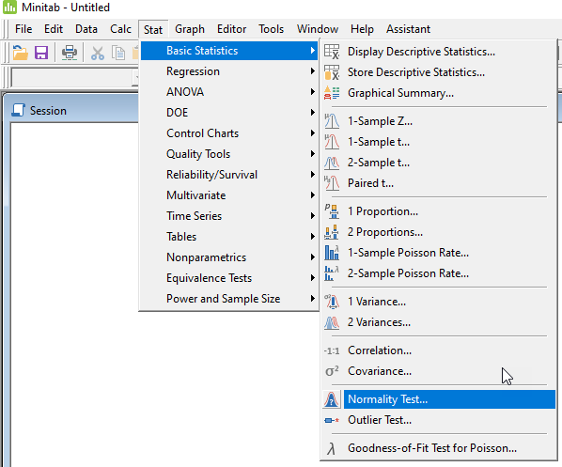
Figure 9: MiniTab screen shot

Enter the column which includes the data into the “Variable” field. In this example the 15 samples are in column C1. Minitab uses Anderson-Darling by default. Use the default setting. Click “OK”
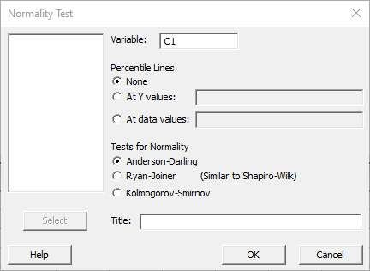
Figure 10: MiniTab screen shot

Step 2: A probability plot of C1 appears. Check the P-Value. If the P-Value is greater than 0.05, the data is normal. The P-Value for this example is 0.346, therefore the normality test passes.
Figure 11: MiniTab screen shot

When Normality Tests Fail

Some but not all reasons for nonnormality are:

Intrinsically nonnormal data such as for example strength measurements. If a nonnormal distribution is expected, state as such in the protocol along with a plan to analyze the data with a distribution that best fits the data.

Extreme outliers. An outlier test may be performed in Minitab (Stat > Basic Stats > Outlier Test). Outliers can be removed if they are proven to be the result of measurement error. As applicable, measurements can be repeated, and the original data may be replaced with the repeat measurement. If the outlier is a result of an instable process, the process should be improved, and the OQ/PQ study should be repeated as required. A time-sequential control chart is recommended to determine if the outlier is caused by process instability. If no root cause for an outlier is identified, the outlier may not be removed from the data set.

Mixed distributions. This could be caused by an unstable process or an inadvertent change in one of the process inputs during the OQ/PQ run. The process should be improved, and the OQ/PQ study should be repeated as required.

Truncated distributions are commonly the result of sorting products before collecting samples for analysis. If a process output does not meet the sampling plan’s criteria, the output must be inspected 100% (this only applies to product characteristics which can be fully verified).

Refer to your local statistical methods procedure for guidance on identifying a distribution that best fits the non-normal data. Once the distribution type is identified, Ppk and Pp may be calculated. Data transformation such as Box-Cox or Johnson transformation should not be used since transformed data are not representative of the actual process.

Calculating Ppk and Pp
Step 1: Select “Stat”, then “Quality Tools”, “Capability Analysis”, and then “Normal”.
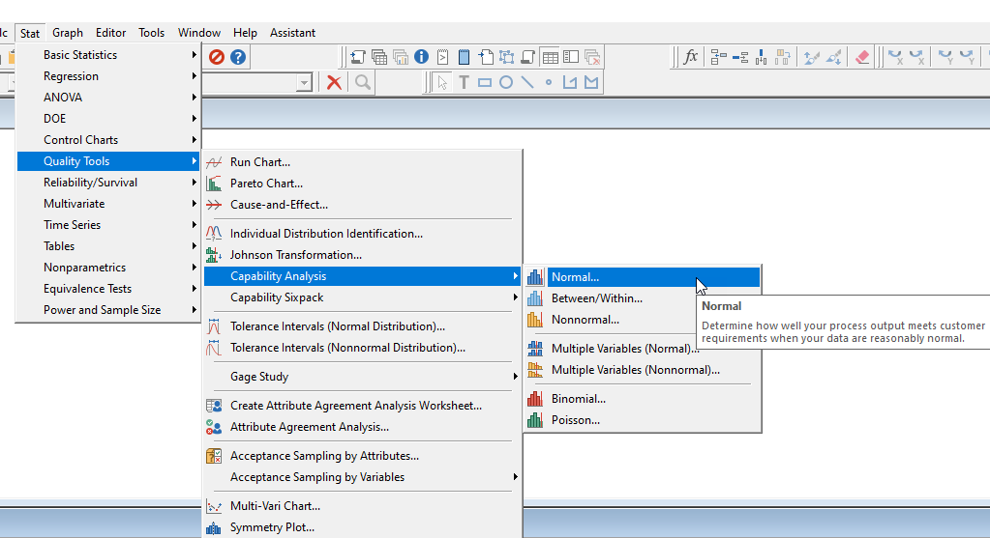
Figure 12: MiniTab screen shot

Step 2: Single column is the default. Enter the column number that includes the data. In this example the data is stored in C1. Chose subgroup size of 1. Enter lower and upper spec as shown.
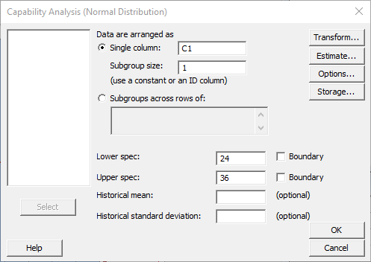
Figure 13: MiniTab screen shot

Step 3: Click on “Options” and Deselect “Within subgroup analysis”. This is specific to the sampling plans, as we only calculate the Ppk and Pp values.
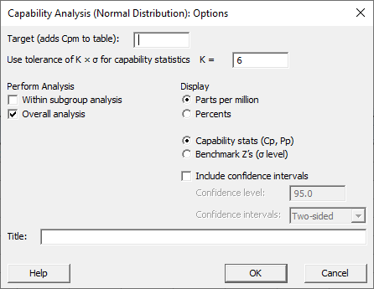
Figure 14: MiniTab screen shot

Step 4: Click OK twice and review the results.
Figure 15: MiniTab screen shot

Manual Processes
Manual processes are not validated in the classical sense. The AAMI Quality System Compendium [Ref-7] states that for manual processes, the process outputs are controlled by a person’s actions. The intent is still to demonstrate that the process is repeatable, and this can be substantiated with a statistical confidence level. [Ref-7] describes some activities manufacturers complete that lead to a conclusion about process capability. In some cases, this is referred to as process output verification where product builds are subjected to testing to ensure they meet pre-defined requirements. In-process inspections and rework steps are included. Samples are taken from the end of the process from those units deemed to be passing by inspections.

Establishing Repeatable Manual Processes

First, sources of variation are minimized. For example, using a custom holding fixture can reduce the variability for an assembly or soldering process.

Second, the work environment is optimized to reduce variability that could arise from improper ergonomic conditions. Examples of improper ergonomic conditions are poor lighting or improper work height.

Third, process operators and inspectors are trained and qualified, and certified to applicable standards. Example: For fuse welding, process welders are certified to an ISO standard, inspectors are certified to an ISO standard, and the welding process can also be certified to an ISO standard.

Equipment is qualified (IQ).

Test methods are validated (TMV).

Work instructions are optimized and challenged by unqualified operators to ensure the instructions are clear and fully understood.

Visual acceptance criteria are established including photos of acceptable and unacceptable process outcomes or by use of “gold standard” samples.

Various qualified operators evaluate the process output to ensure alignment and consistency between qualified operators.

A PQ study is typically executed to demonstrate that the process is consistent and repeatable.

Revalidation
All product design and process changes must be assessed for their impact on process validation, using the process validation plan/report, to determine if revalidation is required. The review includes an impact assessment of the Design and Process FMEA, process validation plan, IQ reports, OQ reports, PQ reports, and TMV reports. If the validated state is impacted by the change, a full or partial revalidation is necessary, and revalidation rigor depends on impact. Revalidation must be executed prospectively and may be necessary under the following circumstances:

Changes to process inputs/parameters are needed.

Test/Inspection methods or requirements change including moving from full verification to SPC or acceptance sampling.

Negative trends in quality indicators.

Product design changes impact process inputs (new raw material, revised product features, revised risk profile) and/or process outputs (requirements are added or revised).

Transfer of equipment/process from one location to another.

Change in PFMEA severity or risk classification (when severity moves from low severity to a higher severity, example S1 moves to S2).

A new CQA (CtS, CtQ, or KPI) is added to the drawing or specification sheet.

Equipment is replaced.

Decision Flow Chart
The following flow chart may be used to determine the validation approach for individual product characteristics. Note that IQ is required for all manufacturing and test equipment used in the manufacture of medical devices.

Figure 16: Validation Flow Chart
*Special processes must be validated even if there is no CQA unless there is a sufficient and approved rationale for why process validation is not required.
**Product characteristics that are no CQAs should always be qualified prospectively to avoid unnecessary inspections in manufacturing. Measurements do not require a TMV but a measurement tool with Accuracy to Tolerance of 25% or less must be used.

References
Ref-1 | GHTF/SG3/N99-10:2004 (Edition 2) Quality Management Systems - Process Validation Guidance https://www.imdrf.org/sites/default/files/docs/ghtf/final/sg3/technical-docs/ghtf-sg3-n99-10-2004-qms-process-guidance-04010.pdf
Ref-2 | Taylor, Wayne (2017), Statistical Procedures for the Medical Device Industry. Taylor Enterprises, Inc. www.variation.com
Ref-3 | MDSAP AU.P0002.008, 2023-04-01 https://www.fda.gov/media/166672/download?attachment
Ref-4 | Code of Federal Regulations (US) https://www.ecfr.gov/current/title-21/chapter-I/subchapter-H/part-820/subpart-A
Ref-5 | Preamble to Code of Federal Regulation 21 CFR, Part 820 – Quality System Regulations, Federal Register: October 7,1996 (Volume 61, Number 195) https://www.fda.gov/medical-devices/quality-system-qs-regulationmedical-device-current-good-manufacturing-practices-cgmp/medical-devices-current-good-manufacturing-practice-cgmp-final-rule-quality-system-regulation
Ref-6 | TMV Guideline, ARIS
Ref-7 | AAMI. The Quality System Compendium. CGMP Requirements and Industry Practice. Third Edition. www.aami.org
Ref-8 | Guide to Inspections of Medical Device Manufacturers, December 1997, Page 9  FDA | Page 9
Table 15: Reference Table

Appendix, Rationale for Sampling Plan Approach
The objective of validation sampling plans is to protect the patient to a commensurate level with the risk tolerated by defect escapes and to prevent a manufacturer from passing validation requirements where the process does not actually meet the predetermined requirements.

Only RQL based sampling plans are allowed for process validation. AQL based sampling plans may not be used. RQL based sampling plans are more stringent than AQL sampling plans. The latter are typically used for normal product release during commercial manufacturing.

Approach to Attribute Single Sampling Plans
The attribute sampling plans in this guideline are based on RQL (Rejectable Quality Level). The RQL of a sampling plan represents the quality level rejected by the sampling plan with a high level of confidence.

Zero acceptance number (c=0) sampling plans are used to provide adequate protection for the patient. The level of protection is shown in Figure 17.

Figure 17: OC Curve for Attribute Sampling Plan, 95% Confidence, 95% Reliability, 5% RQL, 0.086% AQL
The horizontal axis in Figure 17 represents the percentage defective in a validation run. The vertical axis represents the probability that the sampling plan will accept the validation run at that percentage defective. In this OC curve, a validation run with 5% defect rate has a 4.8% probability of being accepted. The graph shows the P(A)=0.048 (=4.8%) probability of acceptance at the RQL = 5%. Therefore, a validation run with 5% defects will be rejected with a probability of 95.2%.

The OC curve also shows that a validation run with 0.086% defect rate has a 95% probability of being accepted. P(A)=0.95(=95%) probability of acceptance at the AQL=0.086%.

Two methods may be used to calculate the sample sizes for c=0 sampling plans.

Method 1: Uses Confidence and Reliability (Reliability = 100%-RQL)
Use the following formula, Reference: Duvage, M.A, 2015 Practical Engineering, Process, and Reliability Statistics, ASQ Quality Press Milwaukee, Wisconsin

$$n=\frac{ln⁡(1-C)}{\ln{(R)}}$$

n: number of samples required for c=0 allowable failures
C: Confidence
R: Reliability
Ln: natural logarithm of a number

Example 1. Sample size calculation for CtS for PQ:
Confidence = 95%, therefore C = 0.95, and 1-C=0.05
Reliability = 99%, therefore R=0.99

$n=\frac{ln⁡(0.05)}{\ln{(0.99)}} =\frac{-2.99573}{-0.01005}=298.073$Round up to the next integer: n = 299

Example 2. Sample size calculation for CtQ for OQ:
Confidence = 95%, therefore C = 0.95, and 1-C=0.05
Reliability = 90%, therefore R=0.9

$n=\frac{ln⁡(0.05)}{\ln{(0.9)}} =\frac{-2.99573227}{-0.10536052}=28.43$Round up to the next integer: n = 29

Method 2: Sample size can be obtained from [Ref. 2] STAT-12, Appendix F] or calculated with software such as Minitab. Refer to an SME for clculating sample size using Mintab.

Approach for Variable Sampling Plans
The variable sampling plans in this guideline are based on both the RQL (Rejectable Quality Level) and a required sample size of n=15, 20, or 30.

The RQL (in literature also referred to as Lot Tolerance Percent Defective or LTPD in short) of a variable sampling plan represents the quality level rejected by the sampling plan on a routine basis (95% probability). The RQL has been established to provide adequate protection to the patient and is directly related to the required reliability. The RQL of a sampling plan is 100% - Reliability in %. For example, the reliability requirement for PQ is 99% and the RQL for the associated sampling plan is 1%. Reliability levels in Table 9 match values typically used in the medical device industry.

The AQL of a variable sampling plan represents the quality level accepted by the sampling plan on a routine basis (95% probability). AQL may be expressed as % non-conformance or as a Ppk index.
For a process to be accepted during OQ and PQ on a routine basis, the estimated Ppk index of the process must be equal or higher than the Ppk value of the AQL. AQL for a given RQL is dependent on sample size. The Ppk value of the AQL increases as sample size decreases. In other words, the fewer samples are tested, the higher the sampling plan’s AQL and therefore the Ppk index of the process must be.

N=15 samples represent the fewest number of samples which should be used for a variable sampling plan for the following reason. Variable data must be tested for normality before analysis commences. 15 data points are required to perform a normality test. Therefore, at least 15 samples are required for the variable sampling plan [Ref-2].

Validation runs with Ppk indices below that of the AQL are rejected with higher probability as shown in Figure 18.

Figure 18: OC Curve for Confidence=95%, Reliability=95%, RQL=5%, AQL=0.024%

The horizontal axis in Figure 18 represents the percent defective in a validation run. The vertical axis represents the probability that the sampling plan will accept the validation run at that percentage defective. In the OC curve, a validation run with 5% defects has a 5.3% probability of being accepted. The graph shows the P(A)=0.053 (=5.3%) probability of acceptance at the RQL = 5%. Therefore, the validation run will be rejected with a probability of 94.7%.

The OC curve also shows that a validation run with 0.024% defects (or a Ppk of 1.16) has a 95% probability of being accepted. P(A)=0.95(=95%) probability of acceptance at the AQL=0.024%.

Values for sample size, AQL, and minimum required Ppk and Pp values for variable sampling plans
from [Ref-2], pages 347 to 403, were used.

The following Minitab calculations can be used to establish the sample size for variable sampling plans. Minitab calculations yield slightly different results than what is presented in [Ref-2].

Select Acceptance Sampling by Variables, Create/Compare as shown below. 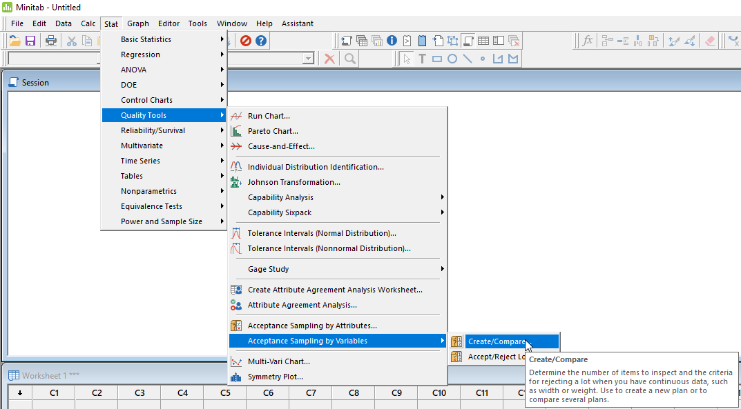
Figure 19: MiniTab screen shot

Step 1: Choose “Create a Sampling Plan”
  - Choose “Percent defective”
  - Enter the sampling plan’s AQL in % into field #1. Example: 0.028 for a sampling plan with RQL of 5% and sample size n=15. Note that the AQL in Minitab is slightly different from the numbers given in [Ref-2]. Minitab only allows entry of RQL and AQL. To obtain a sampling plan for a specific, desired sample size (for example n=15), the AQL must be adjusted. This is done on a trial-and-error basis until the correct sample size is obtained.
  - Enter the RQL into field #2, Rejectable quality level. For instance, RQL=5% enter 5.
  - Enter 0.05 for alpha and beta (for all variable sampling plans)
  - Set -0.5 for lower spec and 0.5 for upper spec (for all variable sampling plans). This is a method to normalize the calculated MSD (makes it easier to calculate Pp from MSD).
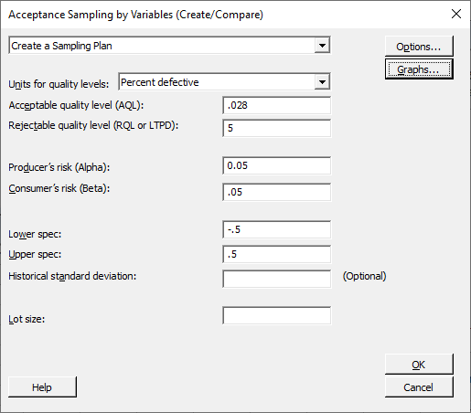
1
2
Figure 20: MiniTab screen shot

Step 2: Click on “Graphs” and deselect ‘Acceptance region plot,’ then press OK twice and review the results.

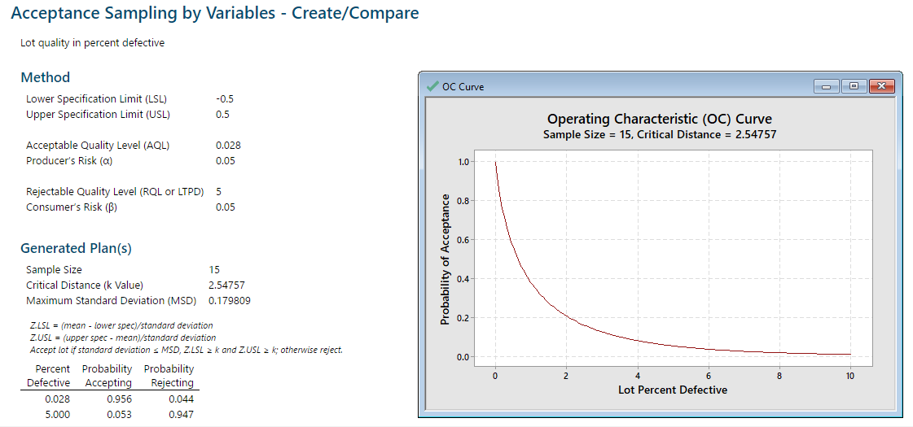
Figure 21: MiniTab screen shot
Note: Minitab does not provide a Ppk or Pp value for the sampling plan criteria. The Ppk is calculated from the k Value.
Ppk = k Value/3, for this example, Ppk = 2.54757/3 = 0.85 after rounding to 2 numbers.
Pp = 1/(6*MSD), for this example, Pp = 1/ (6*0.179809) = 0.93 after rounding to 2 digits

Note: When using Minitab versions 19 and above, click on ‘Options” and select “Calculate the maximum standard deviation with the Wallis procedure”.
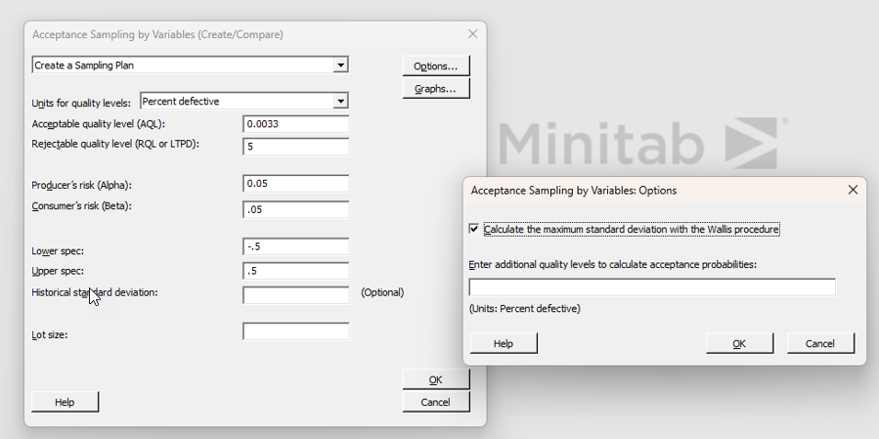
Figure22: MiniTab screen shot

Pp/Ppk versus Cp/Cpk
Ppk and Pp indices are similar to Cpk and Cp whereas Ppk/Pp are calculated using the overall standard deviation rather than the within-subgroup standard deviation. Ppk and Pp represent the actual performance of the OQ and PQ runs including all sources of variation. As such, the Ppk and Pp are the appropriate values for sampling plans [Ref-2, page 329].

